Top Circulations – By Title
First, run a list (Create Lists) for materials using the following criteria (which you can modify to suit needs):
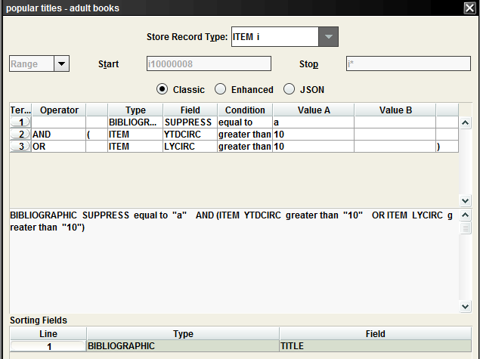
In the above example, you’re looking for bibs with suppress code ‘a’ (adult books) that have either a YTDCIRC (July through now) or a LYCIRC (July-June of previous year) of at least 10 (increase to narrow scope).
Sort by TITLE.
After your results are sorted, export the data using the saved export “popular titles” which will include Title (Bibliographic), YTDCIRC (Item) and LYCIRC (Item).
Open the exported file in Excel as a delimited and check Tab and Comma as your delimiters.
Do a quick scan to see if there are any columns that didn’t render correctly and delete the offending data/shift the cells to the left:
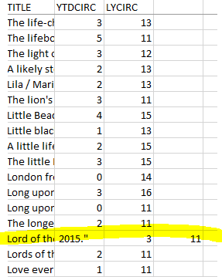
After you’ve cleaned up any wonky data, add a column to the right of TITLE (Column A), YTDCIRC (Column B) and LYCIRC (Column C) and name it TOTALS (Column D). Use the SUM function to sum data in B and C.
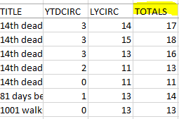
If desired (for easier viewing), hide Column B and Column C so that you only have the TITLE and TOTALS columns.
Click on the DATA tab on the Excel ribbon bar.
Select/highlight the two columns (TITLE and TOTALS) and click on Subtotal. Set it to "Each Change in TITLE", "Use Function SUM" and "Add subtotal to TOTALS".
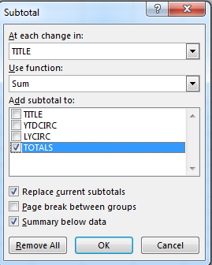
Click OK.
All the items with the same title will be there:
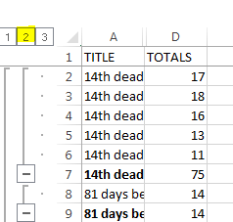
If you click/select #2 on the upper left of the columns (see above), you will then just get the rows with the totals:
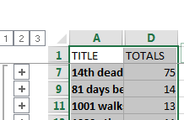
Next, you will sort (Sort & Filter on ribbon, under HOME) the rows by TOTALS, highest to lowest:
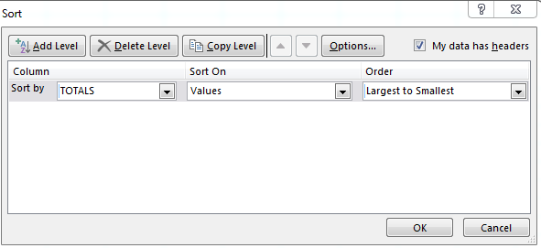
You will now get your desired results:
