When a department returns a set of pages for a section they have inventoried, they will need a new section. The following steps show how to create the report they work from.
- Look on the timeline to see what section that department needs next.
- Open the Create Lists Function to create a list that may be exported to Excel.
- It is easiest to edit a search that has already been completed.
- For the 2018 inventory, there are two lists that are being used for inventory, numbers 13 and 14.
- There are two, because 13 is for a whole location, and 14 is for distinguishing a call number range in a large location.
- Decide which type of list would be better for the report that will be created.
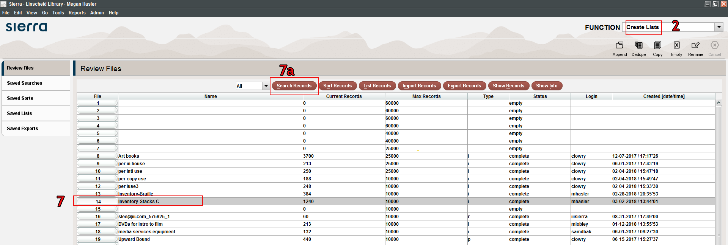
- To start, highlight the list you are wanting to reuse.
- Click the Search Records button at the top of the screen.
- When a warning box pops up, click the yes button
- Type a name for the list in the Review File Name box. It should start Inventory-(area the list is for)
- Next, click the Use Existing Search button at the bottom of the box.
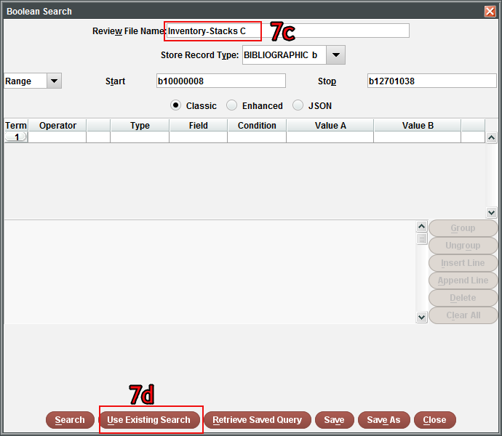
- Highlight the search you want to reuse; this should be the same number of the list you highlighted in number 7 and click use
- Make sure the location (row 1) is correct, for example is it stax2, stax4, ref, etc.
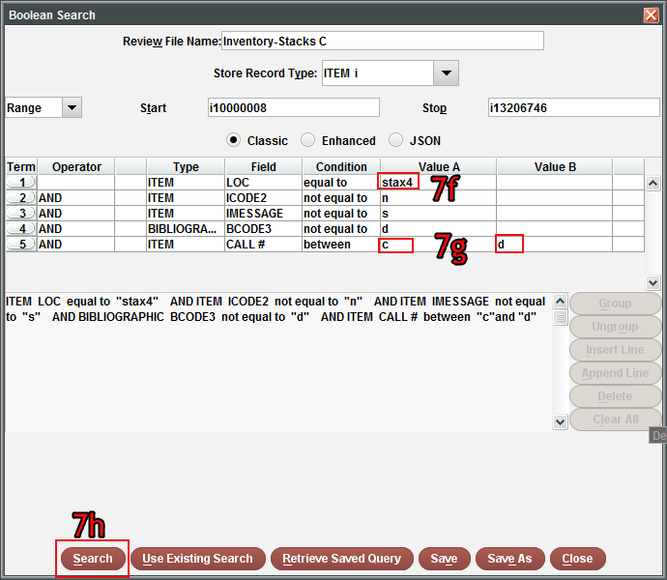
- Adjust the call number range (row 5). You should have the first letter of the call number section you are wanting, and the letter after where you want the range to end. (If you want to look at B-BM you would search B-BN. This will cause it to end at BM9999)
- Once ready, click the search button.
- After giving Sierra time to run the report, highlight the list that was just run again.
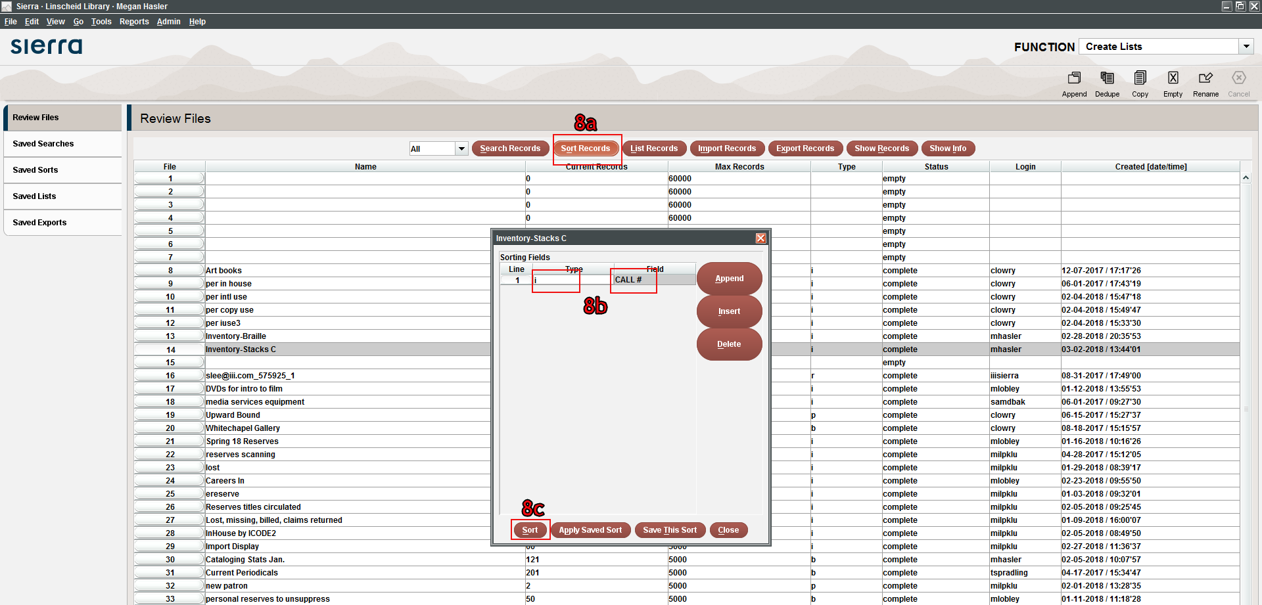
- Click the Sort Records Button near the top of the screen
- Set the type as Item and Field as Call #
- Click sort

- It will take a little time to sort the records. Once it is done, click on the Export Records button.
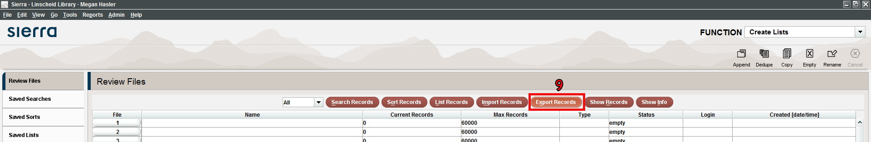
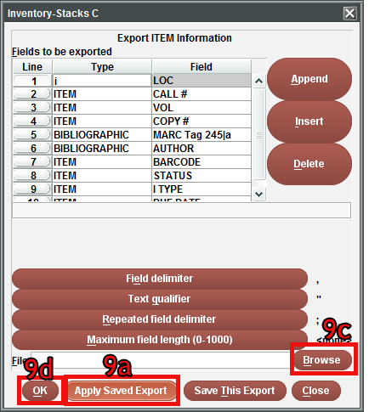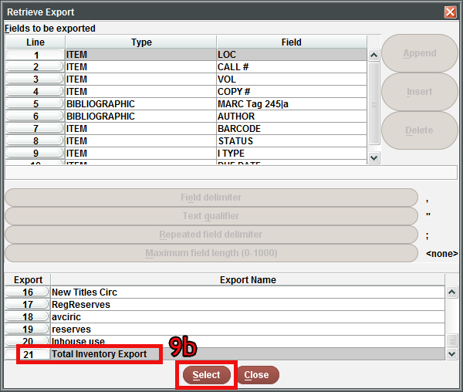
- Click on the Apply Saved Export button
- Choose the export named Total Inventory Export, and click select
- Click Browse – K Drive from the drop down – Library – Technical Services – Inventory – Reports; type in the file name, it should be the location included in the list (Stacks B-BD, Oklahoma Studies, Reference A-E, etc.)
- Click Save, then OK
- Open a Microsoft Excel document
- Open Excel and click Open Other Workbooks → Browse to find the exported file
- Change the file type to All Files, click on the exported text file, and click open
- Choose Delimited → My data has headers → Next 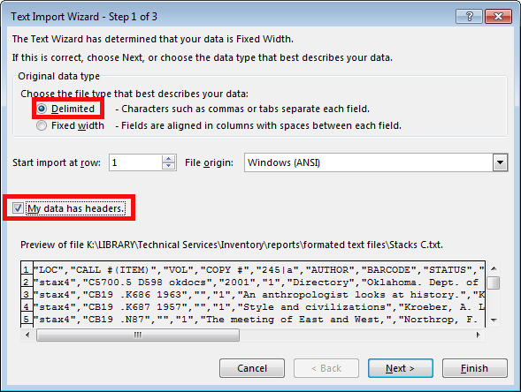

- Choose Delimiters Tab and Comma → Next
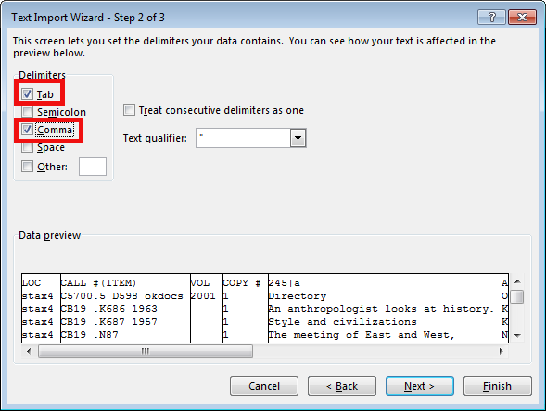
- Choose Column data format/General → Finish
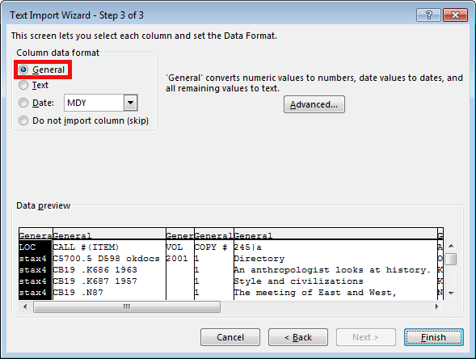
- It is now time to format the report
- The first step is to prepare the report to turn it into a table.
- The first step is to hide the location in column A. Do this by clicking on the A so the whole column is selected. Left click, and select hide. Do not delete this column, it is not needed now, but it will be in the future.
- Second, check at the beginning and the end of the report to make sure that the call number range is correct. Sometimes when running the report, Sierra pulls from the Gov Docs number, you can tell it has done this if the call number in row B is out of the range given for the report (example: Running a report for stacks C, but the end of the report has Library of Congress call numbers in the P’s. If this happens, highlight the rows that should not be included and delete them.)
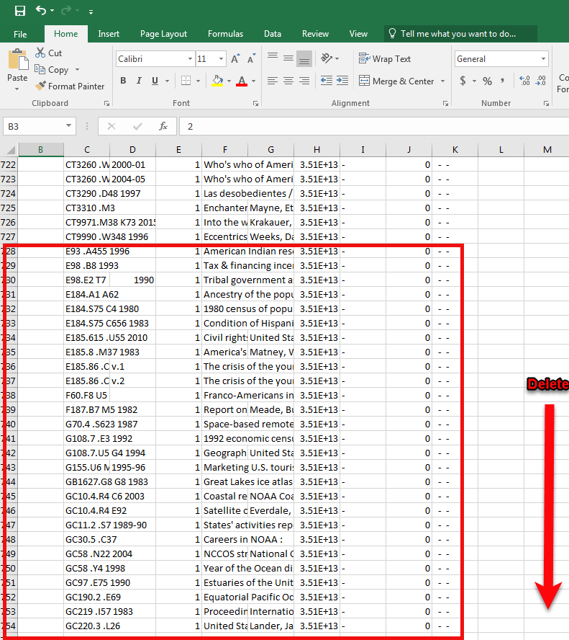
- Next, click on the B column and highlight the whole column. This time, click insert to add a blank column.
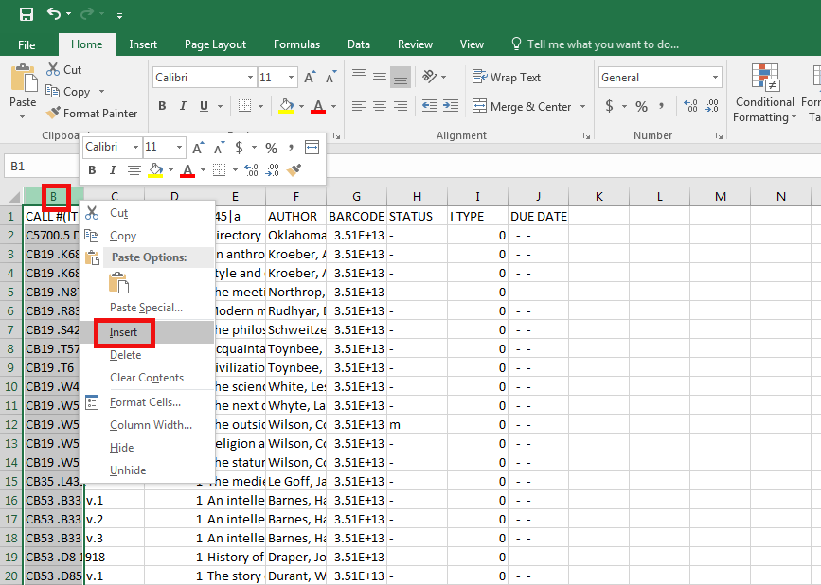
- In the new column that is created, put 3 spaces in box B1, put the numeral 1 in box B2, put 2 in box B3, and then click on box B3, move your cursor until it turns into a black plus, and highlight all of column B until the end of the report. In the little Auto Fill Option box that appears, select Fill Series to have the numbering continue correctly.
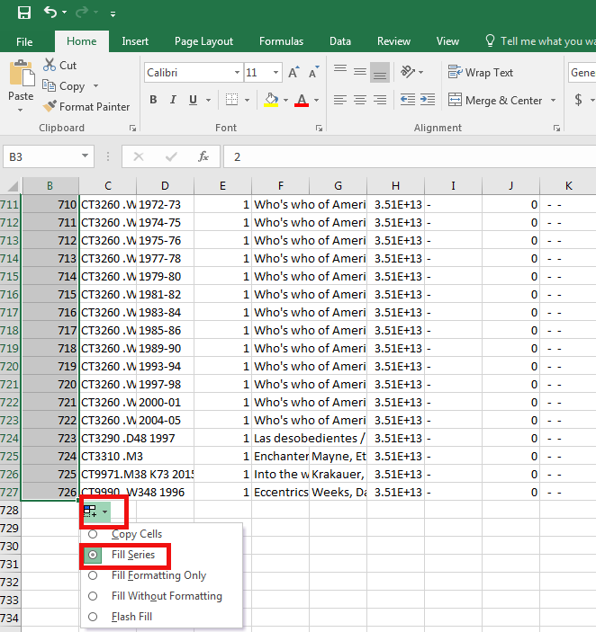
- Stretch out column C wider so the call # in it is more visible. Then click Wrap Text in the home tab. You may adjust the sizing more in later steps.
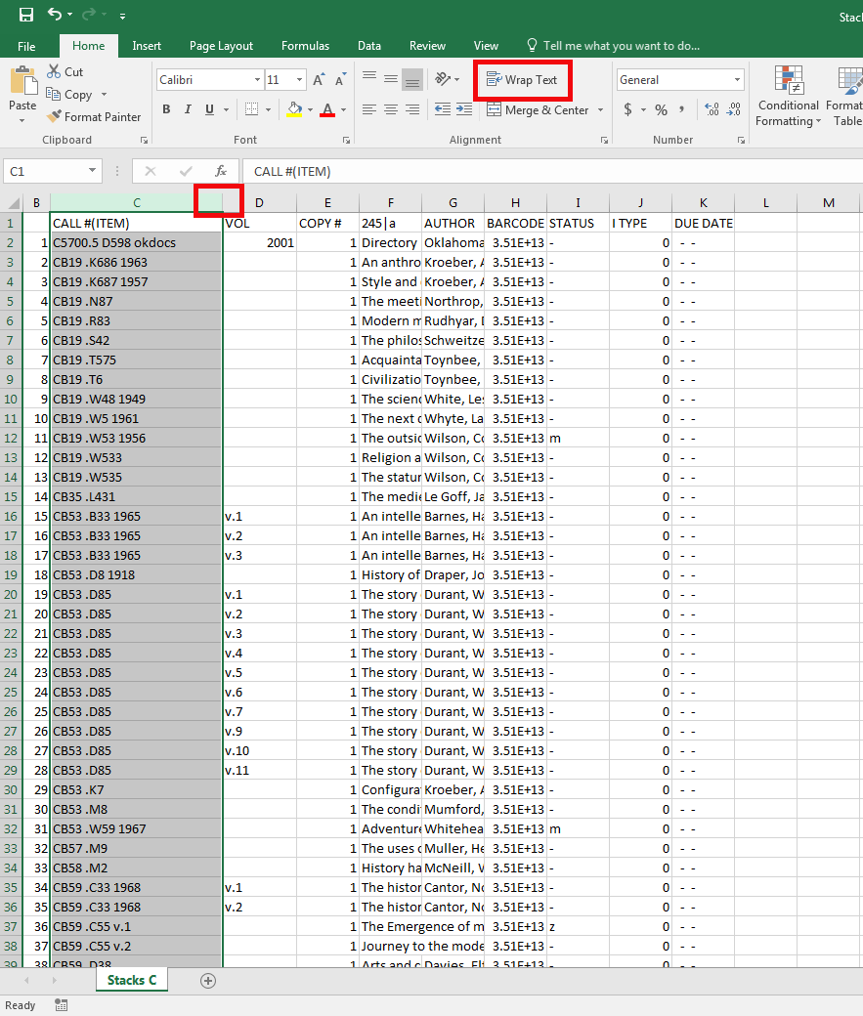
- Double click on the line next to the D for column D to see how wide the column should be. Then shrink the column’s size and click Wrap Text to insure all text is visible. You may adjust the sizing more in later steps.
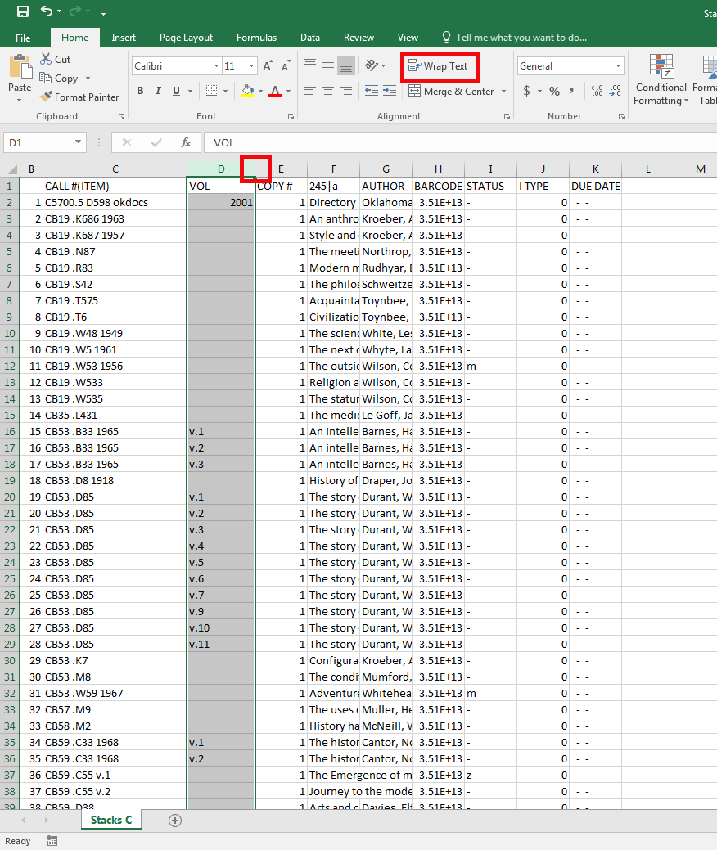
- For column E, sort the numbers by clicking on the Sort & Filter button.
- Select the Sort Largest to Smallest option.
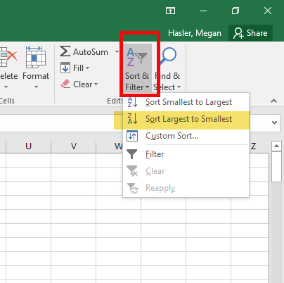
- When it asks if you want to sort the whole page or just that column, you can do either, you will be undoing this step.
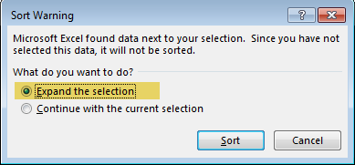
- Once you have sorted the column, if the largest number is one, you may delete the column after undoing the sort. If there is a number larger than one, simply undo the sort.
- For column F, stretch the column out wider and click Wrap Text on the home tab, then change the heading from 245| a to TITLE.
- For column G, stretch the column out wider, and click Wrap Text on the home tab.
- For column H, stretch the column out wider. To have the barcode show correctly, select number from the dropdown menu, then click the button to decrease decimals so there are none in the barcode.
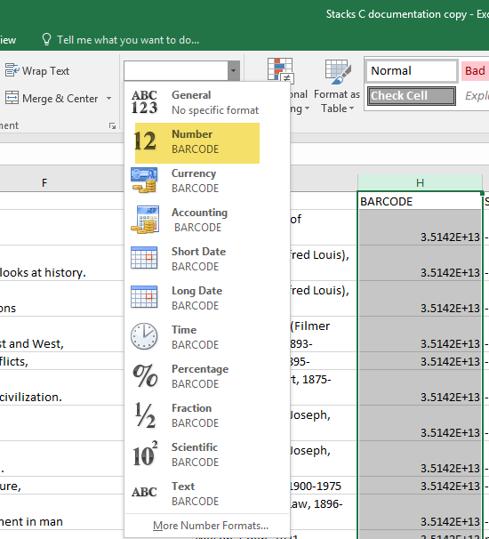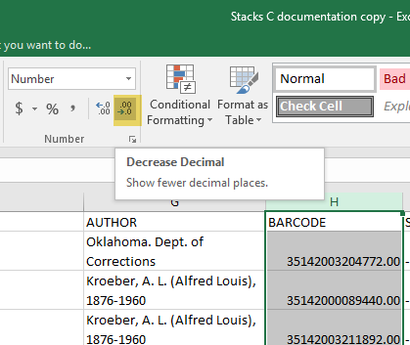
- Column I has multiple steps.
- Highlight the column and sort by clicking the Sort & Filter button and choosing the Sort A-Z option.
- Look at the top and bottom of that column to see if there are symbols different than the most common symbol for that location (depending on the location, this is usually -)
- Write down the numbers in column B for the different symbols, then click undo to undo the sort
- Highlight column I again, then click the Find & Select button, choose the Replace option
- Enter the most common symbol in the Find what box and the full text from Sierra for that symbol in the Replace with box, then click replace all. Make sure the correct column is highlighted before you do this.
- Go to the lines with the numbers you wrote down to fix the status for those items individually. If a large number was different, you may want to do a second Replace All for those, but you will want to plan carefully to make sure you don’t replace something you shouldn’t
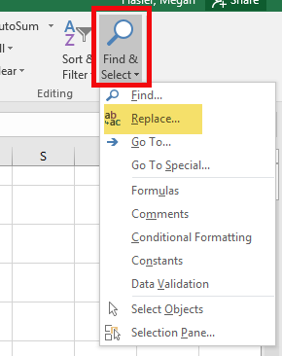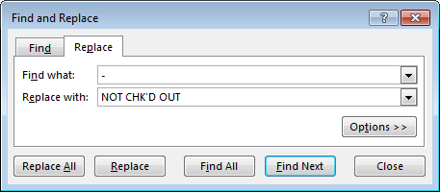
- Repeat the steps from # 18 for the I Type in column J, replacing the symbol with the full word.
- Column K has multiple steps also. This step is important because it shows if any of the books were checked out at the time the report was run.
a) Highlight the column and sort by clicking the Sort & Filter button and choosing the Sort A-Z option.
b) Look at the top and bottom of that column to see if there are dates, rather than the - - symbol, you may have to make the column wider if you see ######
c) Write down the number in column B for the dates, then click undo to undo the sort
d) Scroll to the row for each number that was written down, if the status is NOT CHK’D OUT, then replace that with Due _ _/_ _/_ _ inserting the date from the Due Date column into the blanks.
e) If the status is something other than NOT CHK’D OUT, then ignore the date in the Due Date column.
f) Once all the status are corrected, delete the contents of column K by highlighting it, right clicking, and selecting delete.
- In the new column K, type “Yes” in square K1
- Type “No” in box L1
- Type Notes in box M1
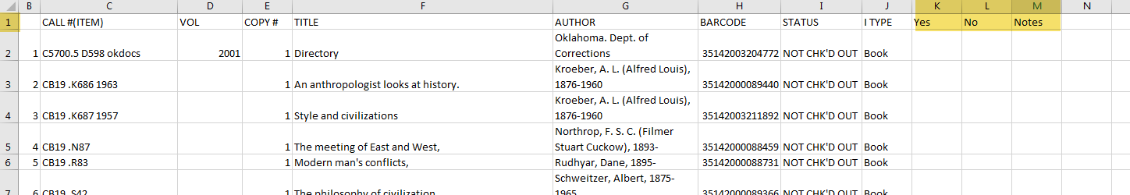
- Now it is time to format as a table. Click in square B1, then click on the Format as Table button and select a table style. Table Style Medium 15 is the preferred style.
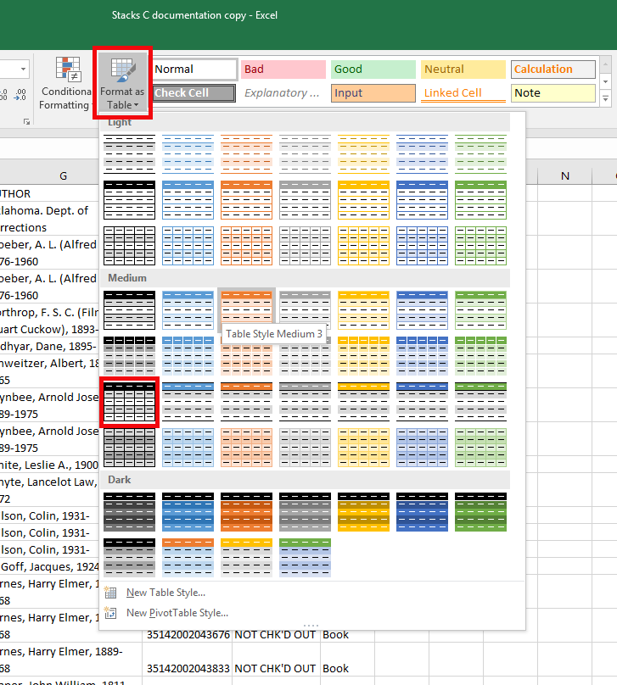
- As an option, the person formatting the report may highlight the squares in row 1 that are a part of the table (B-M) and choose a lighter color than black, such as a dark gray.
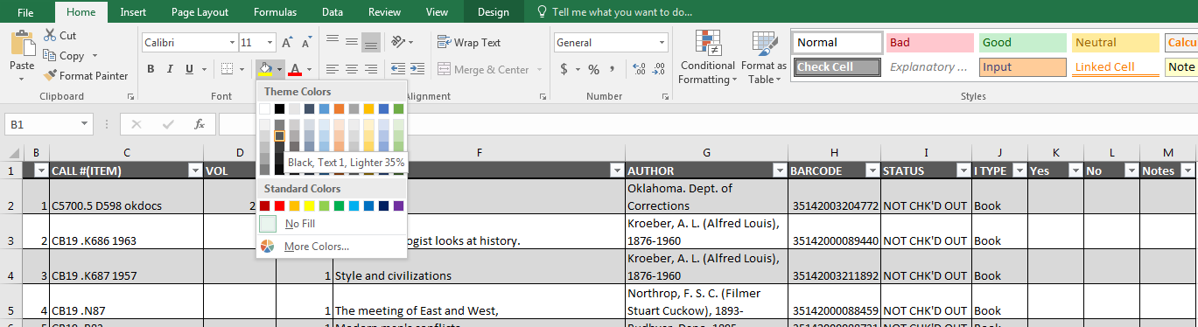
- Now it is time to format the table and the page.
- Under the Page Layout Tab, change the Orientation to Landscape
- Change the Size to Legal 8.5”-14”
- Select the Print Titles Button
- For the Margins tab, change the margins to the following:
- Top .5
- Right .2
- Bottom .5
- Left .2
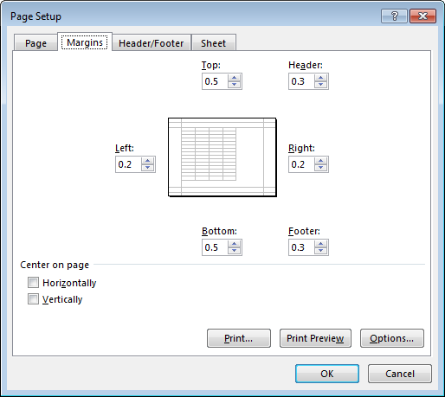
- For the Header/Footer tab, do the following:
- Click the Custom Header… button and add a header to the Center section. Use the location and call number range such as Reference Desk, Stacks F, or Stacks P-PM.
- Click the Custom Footer… button. In the Left section, click the Insert date button which looks like a calendar with a 7 on it to add the date. In the Right section, click the Insert Page number button, which looks like a page with a number symbol. Then type a space the word “of” and another space. Finally, click the Insert Number of Pages button. This adds a page range.
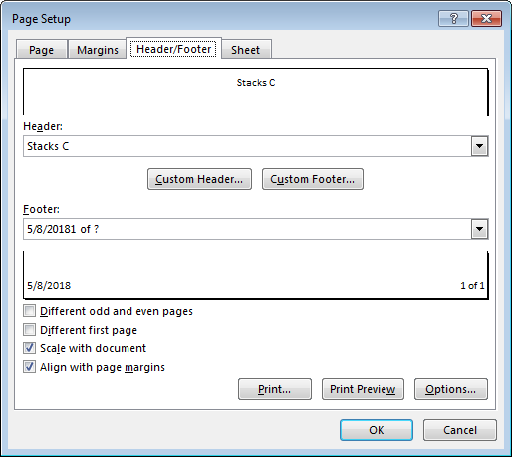
- For the Sheet tab, click on the button next to the Rows to repeat at top box. Click on row 1 to highlight. Then, click on the button next to the box. This will ensure that the headings appear on every page.
- Click the Okay OK button to close the window and make the changes.
- It is now time to resize the columns. It is important to make sure the entire width of a table can fit on a page so playing with the sizes of the columns may be necessary. The following are suggestions to try.
- Start with column b, highlight the column, the place the cursor between columns B and C so it looks like a line with arrows pointing towards both columns. Double click to resize.
- Repeat for columns H, I, J, K, and L
- For column E, shrink the column so that the drop down arrow is over the # sign. The sign will be visible when printing.
- For column M, adjust to make wider so there is room to write notes in the box as needed.
- If the report width is still not on one page (see where the dotted line is, if it is in the middle of the table, the report is not all on one page.
- If more adjustment is needed, experiment with columns C, D, F, and G to make sure the whole page fits.
- For each of the columns where the test has been wrapped, click the Wrap Text button twice more. Sometimes when the size of a column has been adjusted, the text wrapping does not work.
- As an option, it is possible to play with some of the information in the Author column. It is acceptable to remove dates or names in parentheses. Do not spend a lot of time on this, but if it makes a difference on printing another page, it might be a good idea to spend a small amount of time. Start from the bottom and work up.
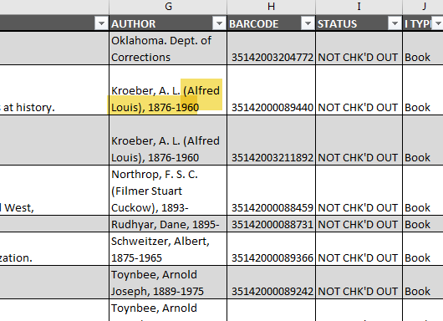
- Finally it is time to print. Click the File tab at the top of the page. Choose print, then make sure the correct printer is selected. If possible, change to print double sided. Make sure that the printer being used has the correct size of paper. Click print.
- Once printed, take to the correct department as determined by the division of the inventory by departments.

