Vega Showcases – Guidelines & Procedures

Introduction
“Showcases” are what Innovative Interfaces calls the section in Vega search results that provide access to related materials, people, and topics in a visual interface, encouraging exploration. If you look at a title on the current New York Times Best Sellers list, for example, you will see the New York Times Best Sellers Showcase:

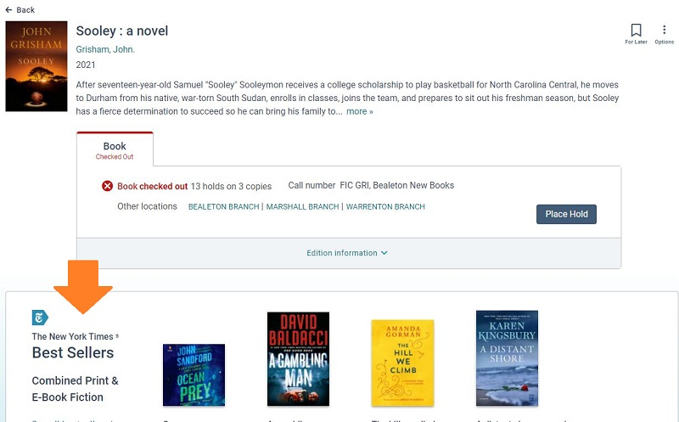

An example of a staff-created Showcases would be the Battle of the Books. If you open a record for a title in the current Battle of the Books list, you will see a showcase showing you all of the other titles in the current Battle of the Books list.

Creating Showcases in Vega is easy – simply log in to Vega with an “admin” level card (see below) and create a booklist of items. You can then publish that list as a Showcase. The Showcase will then display in the Vega catalog when bringing up a title that happens to be included in a Showcase. Otherwise, Showcases are promoted to patrons/the public on the library website, social media, etc., under the direction of the Public Information Coordinator.

The following areas would warrant the creation and ongoing maintenance of a showcase:
- Book Club selections (will maintain current year + previous 2 years); one showcase will be embedded on the specific book club page;
- Book Lists (currently published and/or listed on website) – Examples would be the Battle of the Book lists. These would be included on the What to Read pages;
- Frequently Requested Themes – Examples would be books about Princesses. In many cases, these would be included on the What to Read pages (staff picks);
- Grade Level Bibs – Currently updated annually prior to the SRP and published as handouts. These will be transitioned to online only and are listed on the What to Read (Children) page and associated with a QR code used in SRP literature, signage;

Responsible Staff
Professional staff (library assistants, reference, PSS) will be the primary creators of Showcases. Supervised staff (assistants, reference) will create Showcases (leave at DRAFT status) deemed appropriate and the supervisor will review and publish. For Showcases that will be added to the library website (as a list or embedded, ex. Book clubs, Battle of the Books, etc.), the Public Information Coordinator should be notified and s/he will review, publish and embed or add links as necessary.

Admin Cards
Library Staff (supervisors and professional staff) can create and publish Showcases using the following library card numbers. Please note that the “names” associated with these cards are the first/last name in the Sierra record. The nickname in Vega (when signed in under the card in Vega) should be Library Staff.

- List barcodes and PINs for cards w/showcase privileges here

If you haven’t already done so, please log in to Vega under the staff card number that you will be working under and make sure you put in a nickname of Library Staff.

Creating & Publishing
- Log in to Vega (like a patron would) with an admin card that has showcase privileges. Showcase privileges allow for you to create and publish showcases (no approval necessary). If needed, other staff library accounts can be added and assigned the ability to create showcases that require approval.
- Search for items in the order you want them to display in a showcase and save for later -- click the For Later ribbon…

- You can save to an existing list or choose to create a new one…
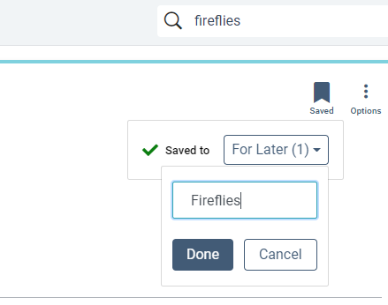
NOTE: If you have already saved a title to an existing list, you will need to go to that list and copy the items to a new or existing list. See https://documentation.iii.com/vega/patron/patron/Procs/Edit_List.htm for specifics on editing lists in Vega
- Click on the Bookmarks tab on the My Bookshelf (runs along bottom of screen or click the ribbon up at the top, where you see your name logged in).
- You will see the lists you’ve created. Click on the 3 dots in the right corner of the list you want to use and select Create Showcase.
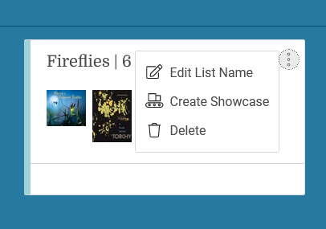
- (Optional) Enter a display name for the showcase.
- Select a sort order if you did not already select/save your items in the order you want them to display (recommended):
- Newest first
- Oldest first
- Title ascending (A to Z)
- Title descending (Z to A)
Please note that Newest and Oldest are not by publication date, but really the order you added them to your list of items.
- Select where you want the showcase to appear.
Currently, the only available option is Record pages. This means the showcase appears on the Resource page for any title in the showcase.

- If you want to display the name of the person who created the showcase, select the checkbox under Display showcase creator. (This feature is selected by default.) NOTE: In order for the showcase creator to display, there must be a Nickname associated with the account (you create the Nickname in Vega when you edit your profile). The Nickname should be Library Staff.

- Select from the options for type, age, and format of the works.

- These selections provide classification information that will be used for future personalization features.

- Do one of the following:
- To save the showcase as a draft, select Save (per the guidelines, these will be drafts until approved by the appropriate staff member, i.e., supervisor or public information coordinator)
- To save and publish the showcase, select Save & Publish.

Maintenance
Lists should be reviewed annually/as needed, primarily by the creator but staff viewing the lists should be mindful of content as well.

Book Clubs – we will keep the current year plus the previous 2 years (3 showcases per book club) – this will mean that the Public Information Coordinator will need to update the embedded showcase code each year, since the list showcase is being replaced vs. updating the records in the showcase

Annual lists – Battle of the Books, etc., that are updated annually we maintain/keep on the current year. The showcase should be updated (not creating new showcases) to avoid requiring the Public Information Coordinator having to update links on the website

Perennial Themes/Topics – Staff may want to add newer titles, remove older (if not deleted from the system the title will remain) annually

Grade Level Bibs - The showcase should be updated (not creating new showcases) to avoid requiring the Public Information Coordinator having to update links on the website

Program-related—should be deleted or made a draft sometime after program is completed.

If a showcase is not linked anywhere (on the website, for example) and the content is no longer relevant, you may delete the showcase.

If a showcase is perhaps not relevant at this time, but may be refreshed at some point, you may unpublish the showcase. Please confirm the showcase to be unpublished is not linked anywhere on the website.

Promotion
In Vega, patrons see showcases when they bring up a specific title. The showcase will fall below the details section, along with topics (subjects), etc. To build awareness, the Public Information Coordinator will embed and/or add links to showcases on the website where appropriate. Showcases may also be shared via social media, newsletters (using QR code or bit.ly links), etc. When staff create a showcase, this information should be shared with the supervisor and the Public Information Coordinator, who will decide the best way to promote the content.

