Creating an Inventory Report using Simply Reports

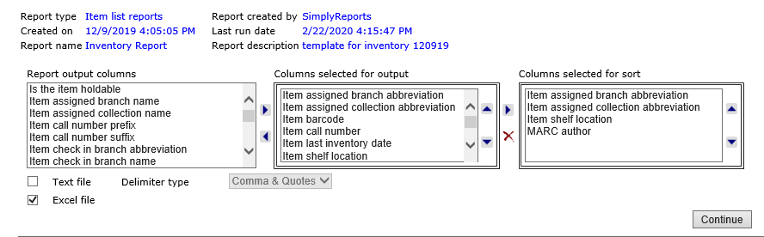

Choose your output columns (Orion uses the following):
Item assigned branch abbreviation
Item assigned collection abbreviation
Item barcode
Item call number
Item last inventory date
Item shelf location
MARC author
MARC bibliographic record ID
MARC title
Item last cko/renewal date
Item material type

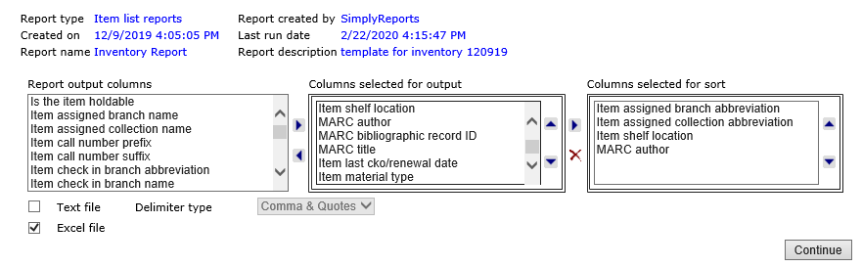

Choose Columns selected for sort (Orion uses the following):
Item assigned branch abbreviation
Item assigned collection abbreviation
Item shelf location
MARC author

Check the Excel file box

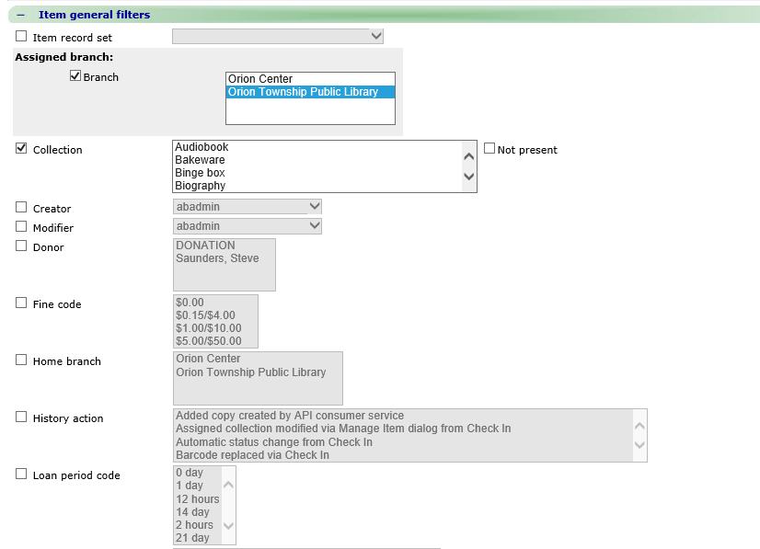

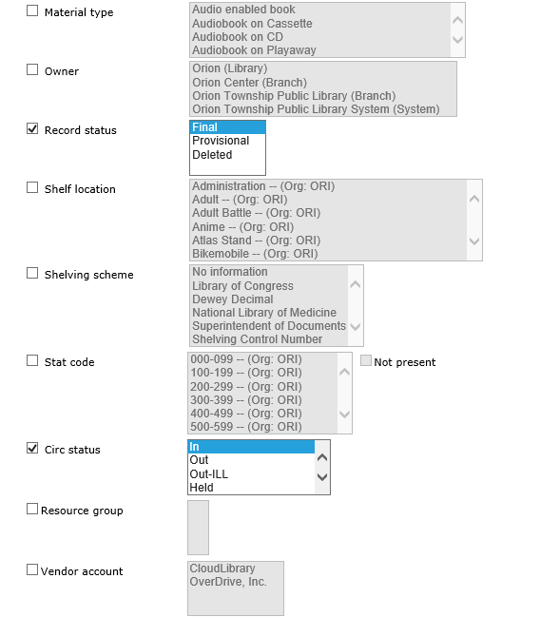
Item General Filters
Assigned branch
Collection
Record status – Final
Circ status – In

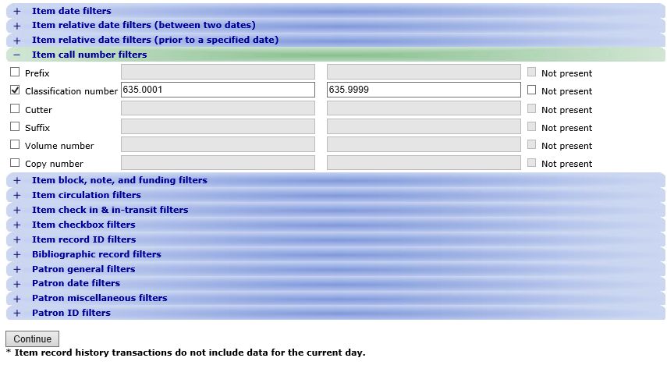

Item Call Number Filters
Classification Number

