Barcode and OCLC Numbers to Bib Record Numbers
Sierra’s create list function has some very useful ways to generate lists through Search Records. You can search by Range, Review Field, Index, and Advanced. Further, you have the option to build queries using the classic layout, enhance layout, or JSON.
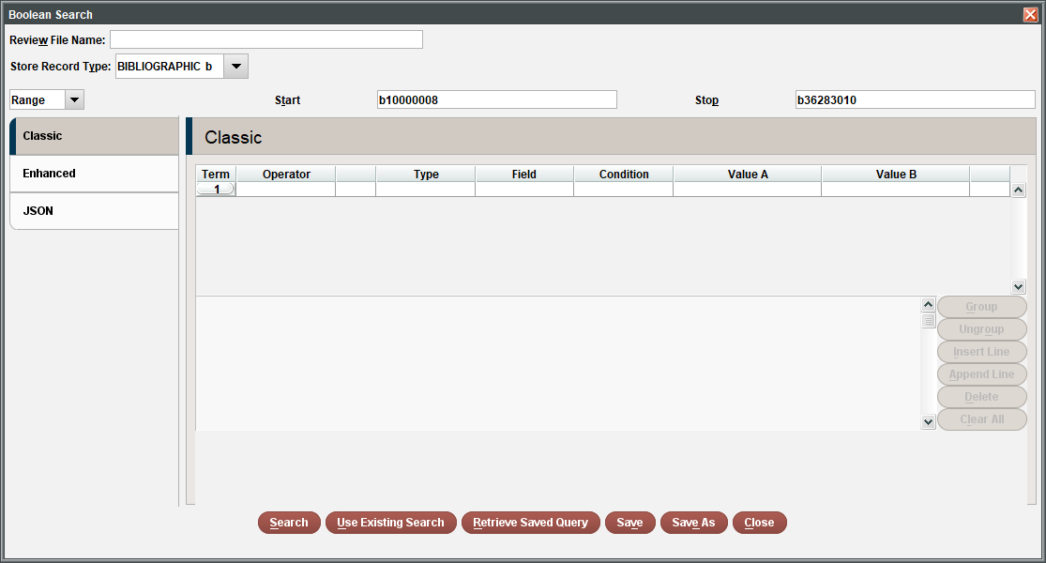
However, one especially useful feature is the ability to import records using a list.
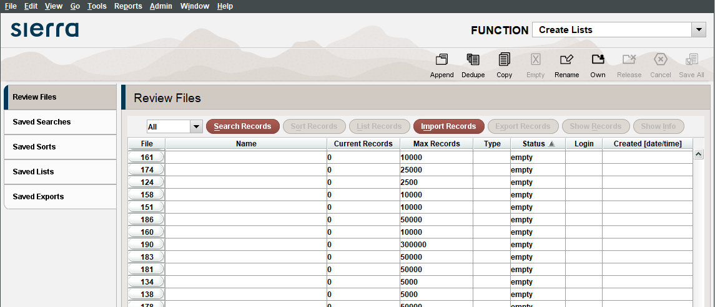
We are able to use the Import Records feature to generate a list of records (any type of record) by importing a list of existing record numbers. The limitation to only record numbers is constraining, but were have developed these workaround to enable us to create lists using other data points. *In a recent update, Sierra has made the ability to import barcodes a part of the default. But we are currently on 5.2. In my case, I’m going to use a tool developed to convert barcode numbers in to bib record numbers.
Why and when would I need to use barcodes to generate a list? In any situation where I have items that need some action performed on them, I can scan their barcodes into a list. Examples include
- A list of books that need to go on display, having their locations changed
- A list of items that need to be weeded, having their statuses changes
- A spreadsheet of data that includes the barcodes, but not the record numbers

Here are the steps in Gary’s barcode to bib number process:
Create or open your list of barcode numbers and save as a .txt or .csv file
Navigate to the barcode-to-record number conversion tool in your browser
Upload the file containing the barcode numbers using the tool’s web interface
It will prompt you to open or save a csv file of the corresponding record numbers
I prefer to open the csv and copy all of the record numbers and paste into a black .txt file and save it
In Sierra, Navigate to Create Lists
Click on a large-enough empty Review File
Click on “Import Records” button
Name the Review file
Set the Store Record Type based on which type of record number you are uploading (e.g. bib record, item record, etc.)
Click Choose File and find the file to import
Click Import

Here are the steps for Elisabeth’s OCLC to Bib Number process:
Create your list of OCLC numbers and save them into a Notepad or other text file
*If you are deleting catalog records, you can take this Notepad list of OCLC numbers, upload it to Connexion and then delete holdings*
Open the OCLC to Bib Number converter tool in your browser
You would then log in using your credentials, and select the OCLC to Bib Number tool
Upload your list of OCLC numbers, after which, you will be prompted to open the newly converted file
From this list of newly converted OCLC numbers to Bib record numbers, you can copy and paste the new bib record numbers into another Notepad file.
You can then take that list of bib numbers, and place it in a review file/Create Lists in Sierra
Make sure the review file you select is large enough to accommodate the number of records on your list
Click on “Import Records” and name your file something recognizable, and make sure you choose the correct file format from the drop-down menu
Click Choose File and find the file to import
Click Import
Your records have now been imported to that review file and you can manipulate them as needed

