Circulation
Quick Start Guide

Copyright © 2015 by Innovative Interfaces, Inc.

This publication is supplied for the exclusive use of customers of Innovative Interfaces with the understanding that it shall not be shown or distributed to anyone outside of the customer's organization without the prior written permission of Innovative Interfaces. This publication may be copied only if the copies are for the exclusive use of staff members of libraries that have purchased the Innovative system.
TABLE OF CONTENTS

Introduction 5
Custom Settings and Preferences 5
New Record Templates 5
System Options 5
Sierra Circulation Functions 5
Check Out (Circulation Desk) 5
Create Patron Records 6
Create Patron on the fly 6
Edit Fixed-length Fields 6
Edit Variable-length Fields 6
Copy a Patron Record 7
Retrieve a Patron record 7
Linking Patrons Records 7
Check Out Tab 8
Items on the fly 9
Checked-Out Items Tab 10
Renewing items 10
Claim Returned 10
Marking Lost Items 11
Change Due Date 12
View overdue items 13
View This Item 13
Print Table (Receipt Printer) 13
Holds Tab 13
Fines Tab 13
Collecting money 14
Adjusting fine amounts 14
Adding Fines to Patron Records 14
Waive Fines 15
History of Fines Paid 15
Patron Notes 16
Check In Tab 16
Search/Holds Function 17
Staff Placed Holds 18
Hold Copy returned soonest 18
Hold Selected Item 19
Cancel Holds 21
Modify Holds 21
Check-in (No Patron) 21
Renew (No Patron) 22
Notices Function 23

Introduction
Sierra Circulation allows staff to do the following: check out items, check in items, place holds, maintain hold queues, maintain course reserves lists, manage fines and bills, and perform other Circulation-related functions. Other optional features are available for purchase.

Custom Settings and Preferences
Many Sierra functions are customizable (for example: screen and text colors, font and font size, new record template creation and maintenance, print templates, and a number of other Sierra functions.) Please refer to the Sierra Circulation eLearning functions in the myINNOU portal for a detailed discussion and instructions on how to optimize the use of the Sierra Circulation functions.

New Record Templates
The Sierra system uses new record templates to create new records. A new record template can be configured by the library to prompt the user to fill in specific fields. A new record template can also be configured by the library to contain default data in certain fields which is automatically inserted into the record during the new record creation process. The library may configure an unlimited number of new record templates in the Sierra System. Please refer to the Sierra WebHelp for instructions on creating and maintaining new record templates.

System Options

There are a number of system options that control certain behaviors within the Sierra functions. These options are used to customize functions such as printing date due slips, renewal policies, etc. They also be used to control numerous circulation options affecting Check out, Check in, Renewals, Holds, Fine/Bill policy and Notices. Access these options from the Sierra Admin Corner in the Administration Application via the following menu path:

A > ADDITIONAL system functions
A > ALTER system parameters
S > SYSTEM codes
O > Set system OPTIONS
C > Circulation options
See the Circulation Parameters Quick Start Guide for information on selected Circulation Options.

Sierra Circulation Functions

Check Out (Circulation Desk)
The Sierra Circulation workflow opens in the Check Out function. This is where most of the daily circulation functions take place, using an individual Patron record.

Create Patron Records
- Click the New button or use the dropdown menu File | New Patron
- Select a new record template from the preferred list or use the default new record template. Record templates can be selected as preferred templates in the dropdown menu Admin | Settings | Record Template.
- Insert values in the fixed- and variable-length fields as prompted by the new record template.
- Variable fields may have been designated as mandatory and/or to be validity checked and this occurs as the record is saved, e.g. email address, if present, must have an @ symbol.
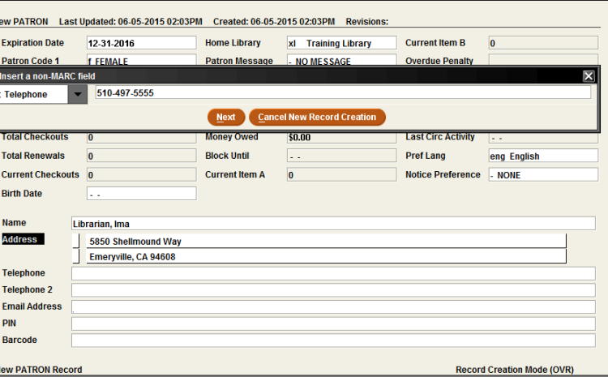

Create Patron on the fly
- Scan or type in a new, unused patron barcode. The system should present a special window for on-the-fly record creation.
- Select a new Patron record template or use the default new Patron record template, according to library policy.
  - In Admin Menu | Settings the template to be used for Patron on the fly can be assigned to the login.
- Insert values in the fixed-length and variable-length fields as prompted by the new record template

Edit Fixed-length Fields
- Use the <Tab> key or click with the mouse to place the cursor inside the white area of the fixed-length field and type in the code, if you know the code you wish to enter
Or, alternatively
- Double-click with the mouse in the white part of the field to display a list of valid codes and/or meanings for that specific field, and double-click on the value to select it.

Edit Variable-length Fields
- Click the Insert icon in the upper toolbar, or use <Ctrl>- I, or the dropdown menu Edit | Insert Field to display a rectangle on the upper part of the screen in which there is a menu of variable-length field choices. Select from the presented dropdown menu by double-clicking on the field then type the data into the white area of the variable-length field display box.

- To move a field within the same field group (i.e.: rearrange the displayed order of several NOTE fields), position the cursor inside the field to move, right-click on the mouse and from the pop-up menu, select ” Move Up”, “Move Down”, or “Move to Top”, or “Move to Bottom of Group”.

Copy a Patron Record
- It is possible to create a new Patron record by copying an existing record. This is useful for entering multiple patrons from a group (for example: a classroom or a family).
- The Library can ask Innovative to specify the fields which are to be copied from existing records into new records using this “Copy a Patron record “function.
- Retrieve the Patron record by searching by barcode or name. If a browse list is presented, select the line by double-clicking on the line or by clicking the “Select” button. Then, click on the Edit icon on the toolbar button. With the selected Patron record open, use the dropdown menu, Edit | Copy Record, to create a new Patron record.
- The data from the original record will be copied into a new record according to the fields you have selected in point number two of this section. It is necessary to edit the new Patron record to change name, add a new barcode, etc. When all changes have been completed, click on the Save icon on the toolbar.

Retrieve a Patron record
Patron records may be searched for by any indexed field using one of the following methods:
- Type or Scan the patron barcode into the query box in the upper left-hand portion of the screen.
- Type the letter “n” followed by the patron’s last name, last name and initial or last name and first name, then press the <Enter> key. This searching option informs the system that it should search the “n” Name Index instead of the Barcode Index.
- Click the Search button and select the index from the drop down list. Type or scan the data into the query box and press the <Enter> key (or click the Search button)
- From a list of Patron records, highlight a line and double-click or click the Select button.
- If you have recently closed a patron record, File Menu|Recent Patrons may allow you to recover it rather then re-scanning the barcode.

Linking Patrons Records
You can maintain groups of patrons within their records using this feature. This is used to link family Patron records or academic assistants to a professor, among other uses.
- Retrieve the Patron record and click the Linked Patrons tab.
- Click the Link button and search for the Patron record to link to the original record.
- Highlight the Patron record to be linked to the original record and click the Select button. Repeat the process to link multiple patrons to one patron.
- To open a linked Patron record, go to the Linked Patrons tab and select the linked patron by highlighting the line. Click the Go To Patron button.
- Once the linked Patron record is selected, click the View Checkouts button to view a linked patron’s checked out materials
- From the Linked Patrons tab, select a patron by highlighting the line. Then click the Unlink button to remove a link.
- This is an optional feature and the tab does not have to display for a login if not required which is controlled in Options | Tabs.

Check Out Tab
- To check out an item, retrieve the Patron record using any of the methods above.
- A brief version of the Patron record displays in the upper right part of the display screen: The information which displays in the brief version can be configured by the library in the dropdown menu Admin | Options | Patron Display. The library may select the fields which display in the brief display by selecting the option for Custom Display and moving selected fields from side to side using the provided arrow buttons on the Patron Display tab.
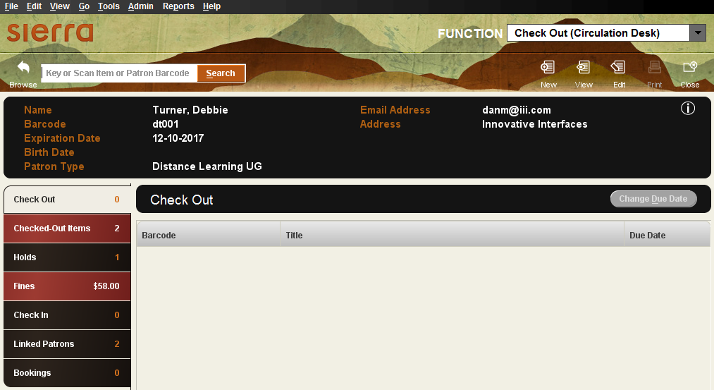
- Scan or type the item barcode in the blank field in the upper left-hand corner of the screen. Alternatively, type “t” followed by the title or “a” followed by the author or click the search button, highlight an index in the dropdown list and enter the data then press the <Enter> key (or click the Search button) and select the item from the list presented.
Brief item details, including the due date, will be shown in the summary display.
- Adding Messages at Checkout is an optional feature which allows you to type in a message which will pop-up to staff the next time the item is checked in. It can be useful for alerting staff to a problem with the item which needs to be resolved once the patron has finished with it (for example, about damage to the item so that the patron does not get blamed.)
Add message at checkout option is enabled in the Setup tab in Options.
- After checking an item out to a patron, it is possible to override the system-selected Due Date: click on the Change Due Date button. (The user must be authorized to override due date. Select a due date from the calendar box presented, decide if this should be used for other checkouts to this patron and if so check the box at the bottom of the display, then click the OK button. . (This might be used to extend a due date if a patron will be away.)
- If the Print slip box is checked, a Date Due slip will be printed when the Patron record is closed. Some functionality of printing slips is configured in the Circulation Options. See the Circulation Parameters Quick Start Guide for more information.
- It is essential to close the Patron record to complete the checkout transaction and to move checked out items into the Checked-Out Items tab. Use <Alt> +Q or click the Close icon in the toolbar to close the patron’s record. Closing a Patron record ensures that the Patron record does not unnecessarily remain “in use” and also protects the privacy of patron information.

Items on the fly
It is possible to create Bibliographic and Item records “on-the-fly” at the time of Check-out for items which are not in the database. Most libraries create default new record templates specifically for “on-the-fly” Bibliographic and item records.
The method of creating an “on-the-fly” Bibliographic and Item record is as follows:
- Retrieve the Patron record using any method.
- Scan or type a new, unused item barcode in the query box
- The system then displays an “Item-on-fly” search screen. It is possible at this point to either search for a Bibliographic record to which the new Item record will be attached, or if no bibliographic record is found, to create a brief Bibliographic and Item record “on-the-fly”.
To create a new Bibliographic record “on-the-fly”, click the New icon on the toolbar:
- Select a new Bibliographic record template, or use the default “on-the-fly” Bibliographic record template if it has been previously set in the dropdown menu Admin | Settings | On-the-fly Records and choosing one template from the dropdown list for each record type.
- Type in or select data for the fixed- and variable-length fields as prompted by the template.
- Upon completing the last prompt from the bibliographic template, the system will automatically continue on to create a new “on-the-fly” Item record. Select a new Item record template, or use the default “on-the-fly” template if it is already established in the Settings.
- Type in or select data for the fixed-and variable-length fields as prompted by the selected item template.
- Upon completing the last prompt, click the Save icon on the toolbar.
- The item will be checked out and will show in the Check Out summary tab.
- Close the Patron record as usual.
Method of attaching “on-the-fly” item record to an existing bibliographic record:
- Open the Patron record with one of the usual methods.
- Retrieve the Bibliographic record by clicking on the Search button and selecting the index from the dropdown box, entering a search term and pressing the <Enter> key.
- Select a new record template, or use the default template if a default “on-the-fly” item template is established in the system.
- Type in or select data for the fixed- and variable-length fields as prompted by the item template.
- Upon completing the last prompt, click the Save icon on the toolbar.
- The item will be checked out and will show in the Check Out summary tab.
- Close the Patron record as usual.

Checked-Out Items Tab

Several functions may be performed using the Checked-out Items tab.

Renewing items
To renew an item from within the Patron’s record:
- Retrieve the Patron record and click on the Checked Out Items tab.
- Select the line from the list of items checked out and click the Renew button.

Claim Returned
If a patron claims to have returned a checked out item, it is possible to mark the item as “claim returned”.
- Retrieve the Patron record and click on the Cecked Out Items tab
- Select the line from the list of items checked out and click the Claim Returned button
- When the calendar screen appears, select the date the patron claims to have returned the item by clicking in the day. Months may move backward and forward by clicking on the single arrow. Years may move backward and forward by clicking on the double arrows. If the patron does not indicate a specific date, click the Blank Date button.
- Choose from the following options.
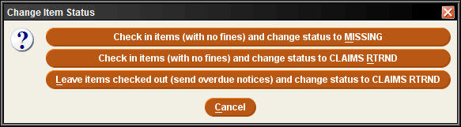
  - All three options place the item into the ONSEARCH FILE (a file of missing items that can be used in a search for the items at a later date)
  - An explanatory note is added to the Patron and Item records indicating that the item has been claimed returned by the patron.
  - A fixed-field in the Patron record is updated to keep a tally of the number of claimed return activities associated with the Patron record for historical information.
  - It is not possible to automatically select or display only one of the three choices presented when the Claim Returned button is selected.
  - A choice must be made in order to continue with the claims returned process.
  - It will be the responsibility of the library to determine library policy and that staff make the correct selection when items are claimed returned.
  - The ability to claim returned is controlled by an authorization.

- Choice 1 – item status changed to MISSING, it is removed from the Patron record and no fines are assessed. The patron is no longer responsible for the item. However, the Claims Returned field in the Patron record is incremented by 1.
- Choice 2 – item status changed to CLAIMS RTRND, it is removed from the Patron record and no fines are assessed. The patron is no longer responsible for the item. However, a note is added to the Patron and Item records and the Claims Returned field in the Patron record is incremented by 1.
- Choice 3 – the system leaves the Item record checked out to the patron and will continue to send overdue notices, generate a bill, accrue fines, etc., and the item status is changed to CLAIMS RTRND. The patron remains responsible for the item, but a note will have been automatically added to the record that the patron reported this item as a claimed returned item. The Claims Returned field in the Patron record is incremented by 1.
If, in the future, an item with a claims returned status is checked in (or out), using any normal check-in or check-out function the system prompts the staff member. The library policy will determine which staff members are authorized to check in a claims returned item. If the selection is “No”, the item remains checked out to the patron. The only way to clear the item status of claims returned is to answer “Yes” to the prompt.

Marking Lost Items
When a patron reports a checked-out item as lost, it is possible to use this function to do the following:
- Remove the item from the list of items checked out to a patron.
- Change the item's status to BILLED.
- Insert a note into the item record reflecting the status of “Lost”.
- Prepare a bill for the lost item to send to the patron.
- Collect all or part of a bill at that moment, or add the bill to the charges assessed against a patron to be retained in the Patron record.
- Change or adjust the billed amount, depending on library policy and authorizations associated with staff that is performing this function.
To indicate that one or more items have been reported lost by a patron:
- Retrieve the Patron record and click the Checked Out Items tab.
- Select the item by double-clicking on the line. After selecting the item (or items), click the Mark Lost Items button.
- The full Item record may be viewed by clicking the View Item button
- The bill amount may be adjusted by clicking the Update Bill button. It is possible to adjust the Item Cost, Processing Fee, and/or Billing Fee if a staff member is authorized to do so:
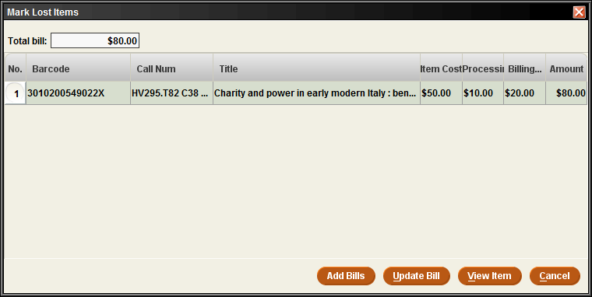
There are three elements of a bill:
- Item Cost: The item cost will be chosen from Item record if the Item record contains a value in the fixed-field for Price. If there is no price in the item record, the system will consult the “Default Item Cost” element from the Loan Rule under which the item has been checked out. Details on Loan Rule configuration may be consulted in the Circulation Parameters Quick Start Guide.
- Processing Fee: This amount is selected from the “Replace Process Fee” element in the Loan Rule under which the item has been checked out. The Processing Fee is an optional field. Details on Loan Rule configuration may be consulted in the Circulation Parameters Quick Start Guide.
- Billing Fee: This amount is selected from the “Replace Bill Service Charge” element in the Loan Rule under which the item has been checked out. The Billing Fee is an optional field. Details on Loan Rule configuration may be consulted in the Circulation Parameters Quick Start Guide.
NOTE: You must Update Bill if there are any changes or adjustments before clicking the Add Bills button.
On clicking the Add Bills button:
- Charges and fees are added to the Patron record.
- The status fixed-field of the lost item is changed to n: BILLED NOT YET PAID when a bill is calculated by the system.
- A note is added to the Item record by the system indicating that the item is billed.
The Fines tab is used to collect money for the lost item.

Change Due Date
Unlike on the checkout tab, changing the due date on the Checked-Out Items tab not only allows selecting a new due date from a calendar, but it also increments the renewals count, so staff should be made aware of this.

View overdue items
The All drop down permits limiting the display to those items which will incur Overdue Notices and Charges, which will display the amount owed if the items are returned that day, and Recalls if there are any for these items.
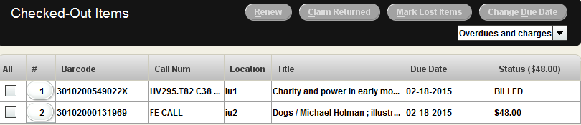

View This Item
Right mouse clicking on one of the checked out items gives a pop-up menu with an option to View Item so that staff can see more detail of the record if required.

Print Table (Receipt Printer)
If a patron requests a print of the checked out items on his account, the Print Button at the top of the screen or right-mouse clicking on a checked out item and selecting Print Table will offer a printer dialog and allow the staff member to choose which printer, if multiple printers are set up for the login, including to the patron’s email address (this will only be offered if the patron record has an email address).

Holds Tab
Holds may be added to a Patron record from this tab. It is also possible to cancel or modify existing holds. See more information below under Staff Placed Holds.
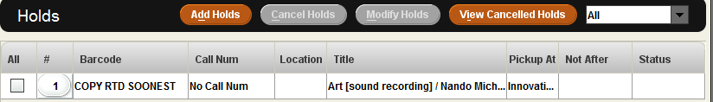

Fines Tab
Within a Patron record, it is possible to view current fines, view a history of fines paid, manually add a charge, waive charges or collect money. The Fines tab displays in a warning color if a patron’s fines exceed the library-defined limit.
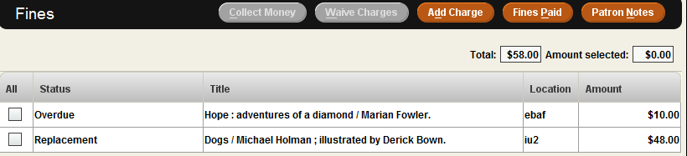

Collecting money
- To collect money for an unpaid fine, retrieve the Patron record using any method and click the Fines tab
- Select the fine(s) by clicking on and highlighting the line(s). Then click the Collect Money button. The checkbox at the left side may also be used to select the fine or fines.
- The system will display as a default the total amount owed for that particular fine or fines but it is possible to accept partial payment. This is determined by library policy. There are no special settings to accept partial payments. Enter the amount and the system will ask if the remaining amount of the fine or bill should be waived. Only staff that is authorized will be permitted to waive fines.
- If the Payment Types table has been enabled, the system will offer a drop-down menu from which to select the type of payment received (for example: cash, credit card, check, etc.) and a payment note field in which to add a note if required. The library can modify the values for Payment Types in Circulation Parameters. Consult the Circulation Parameters Quick Start Guide for details.
- Printing a receipt for the patron is an optional feature. During the fine collection process, if a receipt is desired by the patron, click on the Print button at the bottom of the payment display box, if not required click OK.

Adjusting fine amounts
- In the Fines Tab, select from the summary list of fines. Right-click with the mouse the line pertinent to the fine.
- Choose the View this fine option from the popup menu. The fine detail is displayed.
- Click on the Adjust button.
- Adjust the fine amount.
- Click the OK button to save, or click the Cancel button to exit without saving.
- Only users authorized to adjust fine amounts will be permitted to complete this function.

Adding Fines to Patron Records
This function is used to assess miscellaneous charges to a patron (anything not automatically generated from an overdue item or bill). Examples are: copying costs, damage to library property, ILL services, overdue fine for CL RTRND/MISSING item that is found later, lost library card costs, etc.
- In the Fines Tab, click the Add Charge button.
- Type in the Reason for the charge. A reason is required to assess a manual charge.
- Type in the amount charged to the patron.
- If the Predefined Charges table has been enabled, click the Predefined dropdown menu and choose the charge. Add details to the reason and change the amount, if necessary. If this function has not been enabled on the library system, contact the implementation team if the library is still in implementation, or contact the Innovative Help Desk if the library is an existing customer.

Waive Fines
- To waive a fine, select the fine or fines and click the Waive Charges button.
- Only users authorized to waive fines will be permitted to complete this function.
- If the Payment Types table has been enabled, the system will offer a drop-down menu from which to select the type of payment received (for example: cash, credit card, check, etc.) and a payment note field in which to add a note if required. The library can modify the values for Payment Types in Circulation Parameters. Consult the Circulation Parameters Quick Start Guide for details.

History of Fines Paid
  - To view a history of the fines paid by the patron, click the Fines Paid button within the Fines Tab.
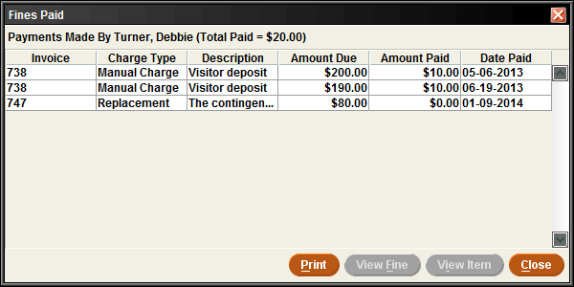
  - To view details about the item pertinent to a fine paid, highlight the line and click the View Item button. The View Item option is not available for manual charges since such charges are normally not associated with a specific item. It is possible to print the resulting screen with the Print button.
  - Click the View Fine button to view the details of a fine or to reinstate a fine.
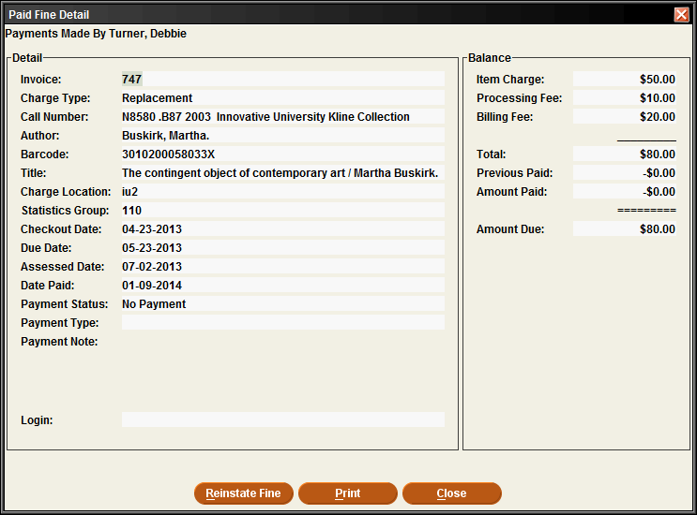
  - To reinstate a fine, click the Reinstate Fine button. A prompt below will appear for confirmation.
  - To complete the reinstatement, click the Confirm button
  - To enable the Reinstate Fine option, consult the Circulation Parameters Quick Start Guide for details. Only staff authorized to reinstate fines may perform this function.

Patron Notes
  - Click the Patron Notes button to view all notes in the Patron record (it is necessary to edit the patron record to add notes).

Check In Tab
When an item is checked in using the Check Out (Circulation Desk)function, Sierra Circulation retrieves and displays the associated Patron record. This function enables you to perform patron-specific circulation functions (such as collecting fines and viewing the history of fines paid by a patron) for the patron who has just returned an item.
- Click on the Check In tab. It is not necessary to retrieve the patron record first.
  - This tab can be used to check-in items from multiple patrons without closing each patron record as the system will change the record displayed at the top of the screen to match the item being checked-in.
- Scan the item barcode.
Some special conditions which affect checked in items
- Backdate checked in items (assign a return date earlier than the current date). This is useful if the library is closed unexpectedly (for example: due to weather or other emergency) and the library does not want to assess fines for unexpected days closed.
  - Click the Backdate button before checking in the materials.
  - Choose the date of return (checked in date) from the popup calendar.
- Check In overdue items
- If a patron returns an overdue item (i.e., the time of check-in is later than the Item record's DUE DATE field), Sierra Circulation generates a fine as established in the Loan Rules, and adds the fine to the Patron record.
- To collect money while still on the check-in tab highlight item(s) in the list and then click on the Collect Money button.
- To waive charges for check-ins highlight item(s) in the list and click the Waive Charges button, or check the box to Waive charges on items being checked in before you start.
- Check In items with holds
- If a patron returns an item which has a hold on it Sierra Circulation will present a message alerting the staff that there is a hold on the item. This offers the opportunity to print a slip or wrapper for the item before it is placed on the Hold Shelf.
- The system sets the item status to On Holdshelf for patron pickup.
- Depending on the library’s notice settings, a hold pickup notice may be generated.
- Check In billed items
- When a patron returns an item which is billed, the system will change the amount assessed in the Patron record to the amount specified by the library. The library has the following options:
  - Reduce the billed amount to:
  - the BILLING FEE
  - the greater of the BILLING FEE or the overdue fine
  - the lesser of the BILLING FEE or the overdue fine
  - CANCEL BILL Only users authorized to waive fines will be permitted to complete this function.
- Consult the Circulation Parameters Quick Start Guide for details on Circulation Options.
  - If required, a receipt acknowledging the return of an item can be printed. The system will print the date & time, title, barcode, patron name, and record number.
    - The routine printing of a receipt acknowledging checked in is set in the Options|Print tab for the login. Even if not the default for a login, a receipt may also be created by checking the Print Receipt box before the item is checked in.

Search/Holds Function
This function allows staff to search the catalog to check the status of items, find titles to help a customer and to place holds if required.
A drop down menu offers the indexes for searching. Select one and type your search term or scan in a barcode

The brief details of the bibliographic record is presented with various tabs
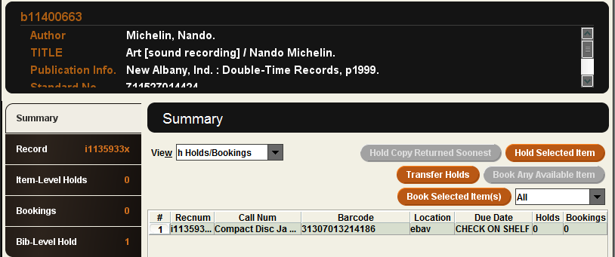
Summary tab displays attached items in a Holds/Bookings view and offers buttons which will be discussed later. The view can be changed to show other attached records if the user is authorized to view them.
Record tab displays the highlighted attached record.

Staff Placed Holds
- There are two types of holds:
  - Bibliographic level holds, which are also called “Title level” or “Copy Returned Soonest” holds. The first copy checked in will satisfy the hold unless the system has been set to obey library policy to refuse a hold under certain circumstances.
  - For item level holds, only a specific copy will satisfy the hold (for example, a particular volume, or particular autographed copy, etc.)
- Under library policy Staff can be authorized to override holds which would normally be blocked.
- Holds can be placed on:
  - A title or item that is checked out
  - A title or item that is not checked out
  - A Bibliographic record for which there are no attached records
  - A Bibliographic record with an attached Order record
  - The library will establish the rules for holds for a login in Admin |Options | Holds tab
- Holds cannot be placed on:
  - An item currently checked out to this patron
  - An item with status o (“library use only”)
  - An item pointing to a Loan rule whose “Code” element is “N” (non-circulating)
  - An item pointing to a Loan rule whose HOLDABLE element is set to “N” (no)
  - Consult the Circulation Parameters Quick Start Guide for information on configuration of hold elements of Loan Rules.
- It is possible to place holds from Search/Holds function or from Check Out function.
  - In Search/Holds search for the title and then click add hold to find the patron.
  - In Check Out search for the patron and then add hold to find the title.

Hold Copy returned soonest
To place a hold from Check Out (Circulation Desk) function:
- Select Check Out function
- Retrieve the Patron record using any method.
- Click the Holds tab
- Click the Add Holds button
- Retrieve the bibliographic record by performing a search, using an appropriate.
- Select the record on which to place a hold by highlighting the line in the browse screen and clicking the Select button. If the search results in a direct hit, the Bibliographic record will be displayed on the screen.
- In Summary tab of attached Item records, click the Hold Copy Returned Soonest button.
- Type in or select the hold parameters and click OK. Hold parameters are configured in Circulation Parameters. Consult the Circulation Parameters Quick Start Guide for details regarding these hold parameters.

To place a bibliographic level hold from Search/Holds function:
- Go to Search/Holds function.
- Retrieve the Bibliographic record by searching an appropriate index.
- If the search results in a browse list, select the Bibliographic record on which the hold will be placed by highlighting the line and clicking the Select button. If the search results in a direct hit for only one Bibliographic record, the Bibliographic record will be displayed on the screen.
- In Summary tab of attached Item records, click the Hold Copy Returned Soonest button.
- Retrieve the Patron record by using the Add Patron button and searching, using the appropriate index.
- Type in or select the hold parameters and click OK.
- The Hold Note appears on paging slips printed for items requested from other locations and displays when staff view holds in Sierra. The Hold Note may also optionally be printed on Hold Pickup notices.
- The number of title-level holds appears in the label of the Bib-Level Holds tab.
- The number of item holds already on a particular copy of a title displays in the Holds/Bookings summary, in the last column to the right as well as on the label of the Item-Level Hold tab as each copy is highlighted.
- If the patron already has a hold on a copy returned soonest, the system will not accept the hold unless the library policy is to allow this.

Hold Selected Item
It is possible to place an item-level hold from Check Out or Search/Holds function.
To place an item-level hold from Check Out (Circulation Desk)function:
- Go to Check Out (Circulation Desk)function.
- Retrieve the patron record using any method.
- Click the Holds tab
- Click the Add Holds button
- Retrieve the Bibliographic and Item record using an appropriate search index.
- From the Summary tab of attached Item records, select the Item record by highlighting the line and click the Hold Selected Item button.
- Type in the hold parameters and click OK
To place an item-level hold from Search/Holds function:
- Go to Search/Holds function.
- Retrieve the Bibliographic and Item record, using any search index.
- From the Summary tab of attached Item records, select the Item record by highlighting the summary line of the Item record and click the Hold Selected Item button.
- Retrieve the Patron record using the Add Patron button
- Type in the hold parameters and click OK
- The Hold Note appears on paging slips printed for items requested from other locations and displays when staff view holds in Sierra. The Hold Note may also optionally be printed on Hold Pickup notices.
- The number of title-level holds appears in the label of the Bib-Level Holds tab.
- The number of item holds already on a particular copy of a title displays in the Holds/Bookings summary, in the last column to the right as well as on the label of the Item-Level Hold tab as each copy is highlighted.
- If the patron already has a hold on this item, the system will not accept the hold
- If no Item records for this title are eligible for hold placement (for example, they all contain a status of “Library Use Only”), the system will display a “REQUEST BLOCKED” message. The system will place, instead, a bibliographic-level hold. By using the bibliographic level hold option, if the library later changes the status of any attached item record or acquires new items for that title for which holds may be placed, the HOLD will be fulfilled. If item level holds are placed, only that particular item may satisfy the hold and if that item becomes unavailable, the hold will never be satisfied.
If the item can be recalled (consult the Circulation Parameters Quick Start Guide for details on configuration of recall elements in Loan Rules), the system will present the following Recall menu options:
- RECALL item with due date of ______________. This can be interpreted as: Accept the system-calculated due date and issue a recall to the patron.
- RECALL item with new due date. (Override the system-calculated due date). A recall notice will be issued to patron with a new due date. If the item is already overdue, it is not possible to specify a new due date. Only users authorized to override the system-calculated due date will be permitted to complete this function.
- Place HOLD without recall. (Place the hold without issuing a recall notice. This does not alter the original due date.)
- Cancel. (This does not place the hold.)

Cancel Holds
Holds may be cancelled from Check Out (Circulation Desk) function and Search/Holds function. The procedure is the same in both functions:
- Retrieve the Patron record ( Check Out (Circulation Desk)function) or Bibliographic/Item record (Search/Holds function)
- Select the Holds tab.
- Highlight the line or lines of the hold(s) to be cancelled.
- Click the Cancel Holds button to cancel all of the selected holds and to generate hold cancellation notices (if you have chosen to send notices for cancelled holds). Consult the Circulation Parameters Quick Start Guide for details on configuration of notice texts and text elements for notices in Loan Rules.

Modify Holds
The hold parameters (for example: not-wanted-before or after dates, hold note, pickup location, etc.) can be changed by authorized users. Holds can be modified either from Check Out (Circulation Desk) function or Search/Holds function. The procedure is the same in both functions:
- Retrieve the Patron record ( Check Out (Circulation Desk) function) or Bibliographic and Item record (Search/Holds function)
- Select the Holds tab.
- Highlight the line or lines of the hold(s) to be modified.
- Click the Modify Holds button to modify the required field of pickup location, the optional not-wanted-before date, the optional not-wanted-after date and the optional hold note.
- If the hold is already on the hold shelf the ‘Pick up by’ date can be changed.

Check-in (No Patron)
- This function is used for checking in materials left at the check-in desk or another book return location.
  - The screen display for checked in materials does not show any patron information, apart from name, and does not offer the opportunity to print receipt or collect money.
  - If you wish to see the patron’s record as you do a check-in, use the Check Out (Circulation Desk) function, Checkin tab. The first checkin will automatically bring that patron’s record to the screen.
Some special conditions which affect checked in items
- Backdate checked in items (assign a return date earlier than the current date). This is useful if the library is closed unexpectedly (for example: due to weather or other emergency) and the library does not want to assess fines for unexpected days closed.
  - Click the Backdate button before checking in the materials.
  - Choose the date of return (checked in date) from the popup calendar.
- Check In overdue items
- If a patron returns an overdue item (i.e., the time of check-in is later than the Item record's DUE DATE field), Sierra Circulation generates a fine as established in the Loan Rules, and adds the fine to the Patron record.
- Users must be authorized to check in overdue items in order to perform this function.
- Check In items with holds
- If a patron returns an item which has a hold on it, Sierra Circulation will present a message alerting the staff that there is a hold on the item and giving the opportunity to print a slip or wrapper for the item before it is placed on the Hold Shelf.
- The system sets the item status to On Holdshelf for patron pickup.
- Depending on the library’s notice settings, a hold pickup notice may be generated. Consult the Circulation Parameters Quick Start Guide for details regarding notice texts and Loan Rules.
- Check In billed items
- When a patron returns an item which is billed, the system will change the amount assessed in the Patron record to the amount specified by the library. The library has the following options:
  - Reduce the billed amount to:
  - the BILLING FEE
  - the greater of the BILLING FEE or the overdue fine
  - the lesser of the BILLING FEE or the overdue fine
  - CANCEL (Only users authorized to waive fines will be permitted to complete this function.)
- Consult the Circulation Parameters Quick Start Guide for details on Circulation Options.

Renew (No Patron)
The Renew function can be used to renew items without accessing a patron record:
- Change the current function to Renew (No Patron)
- Two methods of renewing an item are possible:
  - Scan or type in the barcode of the item to be renewed
  - Search by Item record number, and then select the item to be renewed
- Click the Close button

Notices Function
The notices that can be sent to a patron are governed by settings in the Loan Rules for courtesy notices, overdues, recalls, hold pickups, cancellations and bills. Other patron notices such as statements of charges or checked out items can be sent on an ad hoc basis by library staff.
Staff notices such as paging slips or lists are generated according to Options and hold parameters.
The Library may have purchased optional features which also have notices associated with them, such as In-Reach or Telephone Notification.
Manual notice preparation function is the default setting. However the optional Auto Notices feature can be enabled by Innovative. For libraries in the implementation process, consult with the implementation team. For established Innovative customers, use the Service Commitment section on CSDirect to request that this feature be enabled.

Notices are prepared and delivered using Notices function.
- Notice jobs can be set up for the various types of notice and for different libraries if required, so that all that is necessary on a daily basis is to select the job to run.
  - Overdue notice jobs will only be able to be run once a day, but a hold pickup notice job can be run more often if required.
  - If the feature is enabled, a notice job can be set as auto-notice which the system will run automatically.
- Click the New button to set the parameters for a notice
- Select a Notice Type from the dropdown menu.
- Select the Location which may be limited by your authorization to just the locations served associated with your login. If you are authorized for ALL locations, select this with care as it will run and clear those notices for the whole system. If you are authorized to select an individual location from the drop-down list, be aware that this will create a notice for a single item location as it is not possible to choose multiple values from the list.
- Sort the notices as desired, using the Sort by button (this could group notices together for ease of dispatch).
- If using email notices, choose an email subject from the list.
- If an auto-notice is required, check the box to enable it and decide how to set Move all notices to print (perhaps a final overdue is for staff use or the bill needs to be printed on headed paper or sent to a finance office to be dealt with) and Send via FTP (perhaps the notices are sent to a third-party for production and dispatch)
- If the library has used iReports (Print Templates) to design the layout of the notices to produce print templates, select from the list.
- in the Options section for Overdue notices, set an Overdue Level, or Overdue Status and for all notices set the address to be used (by default notices use address 1 from the patron record, but for a particular ptype or a particular time of year, it might be necessary to use a second address)
- Click the Prepare button or File | Prepare from the dropdown menu
- When setting up a job it is necessary to select a printer from the choices offered by your login and click the Print button to confirm. If the choice was to print to email you will be asked to enter an email address and if to a printer and your PC has multiple printer choices, you will be able to select the one you wish to use.
- When running an existing job you may also be asked to confirm the printer or email address.
- After the notices are prepared, the system is ready to generate them depending on the delivery methods available to you: print, send via email or (if purchased) Teleforms or SMS. A dropdown menu will display the delivery options and selecting one will show the individual notices, by patron, available for that delivery option.
- After the delivery method has been selected in the dropdown, click on the Send button.
  - For email notices it is possible to use the Move All to Print button to print them (useful if there is a temporary problem with your email server or you need a hard copy of the notices for some reason).
- A window will pop-up with Send entries 1-NN (total number of that notice). Click OK to generate the notices. (If you wanted to run a test you could set the ending number to generate just a few of the notices)
- A window will pop-up showing the progress of generating the notices and when complete another window will show the total number sent and ask whether to Clear all notices of that type. Only click Yes if you are sure as they will not be available again once this is done.
- A Summary tab will display the statistics for this notice set and if email notices the Email tab will show a number in the label and the title and call number of the item(s) will be listed. If there are problems Items Not sent or Records in use will be red and show details. If a record could not be updated because it was in use, it will come up for a notice again the next time that job is run. A tab display will display “Items not sent”,” Items in use”, “Emails”, and a Summary statistical tab.
- When you have finished, click the Close button and if it is a new job or the settings have been changed, the system will ask if you want to save it and if you do, you will need to confirm the printer and the job name.

