**Merging Patron Records**

**Two** **records may exist for the same person. A customer may have a record under a new name but still have a record under a former name, or a duplicate record with the same name may have been created in error .You can merge the patron records to resolve the issue.**

* To merge the records open the **primary record** (*the record that will retain the data)*.



* Click **Tools>Merge with Patron**. The **Patron Merge** dialog box appears showing the Primary record information.
* Click **Select record to delete** to locate the secondary record to be merged with the primary record. The patron code, registered branch, address, stat class, UDF values, and so forth from the primary record is retained. Patron transaction summary information (such as items out, fines, holds, associations) is copied from the secondary record to the primary record.
* Click Merge

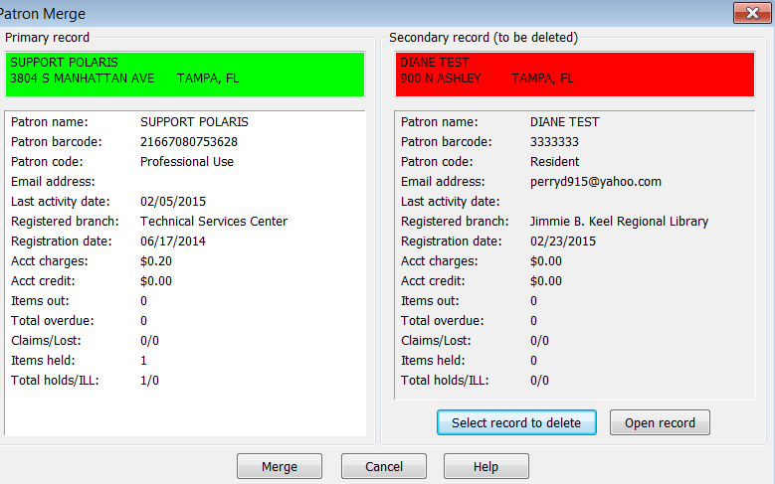

* When the records are merged, the secondary record is deleted.

**Blocks to Merging Records**

There are certain conditions that will block the merge:

• The **Do not delete** option is checked in the secondary record.

• The primary or secondary record has a collection agency block.

• The secondary record has Held or Shipped hold requests. The message indicates that the holds must be cleared before merging.

**Effects on Patron Record Information**

When the merge is successful, the records are affected as follows:

• **Registration Data** - The primary record’s registration data remain. The secondary record’s exemptions, preferences, are not copied to the merged record.

• **Barcode** - The patron barcode in the primary record does not change. The secondary record barcode appears in the **Former barcode** field of the primary record.

• **Patron Code** - The patron code in the primary record does not change.

• **Last Activity Date** - The most recent Last Activity Date, regardless of record, is used in the merged record.

• **Date of Original Registration** - The earliest Date of Original Registration, regardless of record, is used in the merged record.

• **YTD and Lifetime Use** - The YTD use and lifetime use counts of the secondary record are added to the counts for the primary record.

• **Blocks**

• All free text blocks are copied from the secondary record to the primary record.

• Library-assigned blocks are copied from the secondary record to the primary record. If there are duplicates, the blocks in the primary record are retained.

• **Items Out** - Copied to the primary record.

*Note:   
In the linked item records, the Current borrower field is updated to the primary record, and the Last borrower field is updated to the secondary record. All other item data remains unchanged*.

• **Notice history** - The secondary notice history is added to the primary record.

• **Claimed items** - The secondary claimed item information is added to the primary record, and the current claim and/or lifetime claim count is updated in the primary record.

• **Lost items** - The secondary lost item information is added to the primary record, and the current lost item count is updated.

• **Patron account** - The secondary record’s current charges and payments are copied to the primary record, and the total charge, payment, amounts are updated. All account summary transactions are also copied.

• **Hold requests** - If the secondary record has any attached hold requests with a status of Active, Inactive, Pending, Cancelled, or Not-supplied, the hold request is updated with the primary patron information, and the requests are added to the Holds view of the primary patron record. The requests maintain their queue positions, but the patron record linked to the request changes to the primary record.

*Note:   
If there are duplicate Inactive, Active, or Pending hold requests, the older one is retained and the other is canceled. A note is added to the canceled request.*

• **Associations** - The primary record retains any associations it already has, but is not affected by any associations in the secondary record.

• **Patron messages** - Messages attached to the secondary record are not copied to the primary record.

• **Reading history** - The secondary reading history and any ratings are copied to the primary record, and the items are sorted by check-out date. Duplicate titles are not deleted.

• **Notes** - Secondary blocking and non-blocking notes are copied to the primary record. A blank line separates the copied notes and any existing notes in the primary record. The system adds the following note to the top of the primary record’s **Non-blocking note** field: **Patron record was merged with [barcode], on [date]. The secondary record has been deleted.**

• **Notices** - Overdue notifications initiated for the secondary record will be sent to the primary record in sequence. For example, if the secondary record received a first overdue notice before the merge, the primary record will receive the second overdue notice after the merge. If the secondary record exceeded the fine notice or collection agency threshold before the merge, the primary record will receive the notice after the merge.