**Notification Options: Choosing and Using Print, Telephony, Email and Texting**

**2016 Innovative Users Group Meeting**

**Wednesday, March 16, 2016**

Deborah J. Lewis, Onondaga County Public Library System

With revisions by Aaron Neslin, Onondaga County Public Library System

**Environment:** City libraries combined with existing NYS public library system in the 70’s – system is now 32 buildings across a single NY upstate county: 19 members of the system, including a system central library and 10 city branches. Somewhat cooperating federation:

* Single card valid in all libraries
* Hold shelf time different – 5 or 7 days – which makes creating a single message difficult, but, 32 separate branches make customizing this for each a pain
* Notification periods the same for all libraries
* Fines different across members, applied based on lending library
* Grace and free days different across members, applied based on transacting library
* The system has always centrally run and printed notices on behalf of all of its libraries
* We’ve never mailed/provided bills
* We started using collection services (UMS) in 2005 – all libraries
* Overall, circulation is roughly flat in the county
* Migrated to Polaris ILS from Dynix in 2007
* Most of our Polaris servers are now virtualized on blades in our County Data Center, but our telephony server remains on-site at the system.

**B.P. (Before Polaris):** smudged multi-part NCR-paper mailer printed in dot matrix printer – required full postage but contained details of holds and overdues. *Also, many of the branches and member libraries had staff or volunteers call patrons when holds came in for them.* Early 2000’s: as many as 150,000 mailed notices/year.

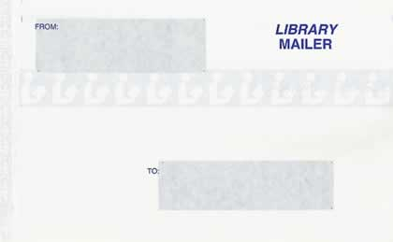 MC900282708[1]

**Now (Polaris 5.0.385):**

* Email (holds, overdues, **almost due**, **hold cancellations**)
* Email for almost overdue as an opt out
* Outbound and inbound telephony (holds, overdues, plus call-in automated attendant)
* SMS/Txt Messages (patrons can add to any other notification method)
* Mailed postcards (holds and overdues only)
* Patrons get to choose their notification method

|  |  |  |  |  |
| --- | --- | --- | --- | --- |
| OCPL Patrons by primary notification type, 4/2012 | | |  |  |
| **Mail** | **Email** | **Phone** | **Txt** | **Total** |
| 7,472 | 71,083 | 105,507 | 1,051 | 185,113 |

|  |  |  |  |  |
| --- | --- | --- | --- | --- |
| OCPL Patrons by primary notification type, 3/2016 | | |  |  |
| **Mail** | **Email** | **Phone** | **Txt** | **Total** |
| 7,937 | 102,422 | 112,056 | 5,327 | 237,376 |

|  |  |  |  |  |
| --- | --- | --- | --- | --- |
| **Polaris report:**  **Notification fiscal year comparison:** | | | | |
| **Year** | **Mailed Notices** | **Email Notices\*** | **Phone Notices** | **Total** |
| FY 2015 | 32,137 | 953,251 | 222,022 | 1,207,410 |
| FY 2015-2014 % change | -5.46% | 6.38% | -7.27% | 3.24% |
| FY 2014 | 33,994 | 896,047 | 239,435 | 1,169,476 |
| FY 2014-2013 % change | -17.46% | -7.66% | -9.33% | -8.33% |
| FY 2013 | 41,187 | 970,426 | 264,081 | 1,275,694 |

*note: no separate TXT counts in this version of Polaris, but promised via the Help file.

**The Big Notification Decisions**

* Email notification? Yes! Our preferred notification method. We have a Microsoft Exchange Server.
* Pay for telephony server, Polaris software, and phone calls? Yes, or pay a service to do it! Faster notification for patrons, less staff/volunteer involvement, so cost is worth it. Downside: *staff* feel less service is provided to patrons.
* Do we retain mailed notices? Had to directly after migration, as patrons used to it. Switched to postcards, though, for cheaper postage and mailer cost. Continue to recommend alternatives to patrons. Still backup to failed telephony notification.
* SMS/Txt notification? Sure - why not? Just specialized email.
* What notices to send? Check Polaris documentation for options.

**General Notification Information**

* In Polaris 4.0+, all notices editing is done via the Polaris Language Editor– http://[your catalog URL]/webadmin

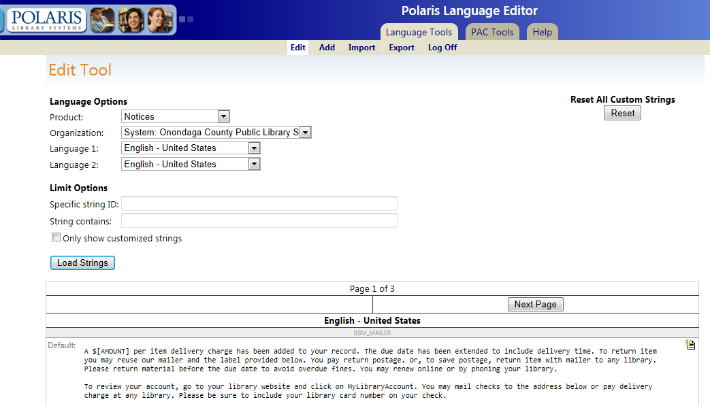

* There are a variety of reports available now about notifications – some useful, some not so. See Polaris Help for more information on available reports.

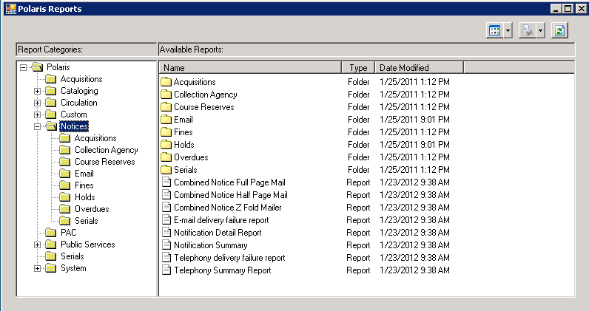

**General Issues**

* Often your choice for notification methods is “Patron preference” or one of the other choices. You can choose the method by notice type – except holds cancellations and almost overdue notices (email only).
* In Polaris 5, email notifications are always sent for almost overdue/auto-renew unless a patron is excluded by opting out.
* If the notices are managed at a system level for consortial organizations, it can make wording difficult if different policies for e.g., holds shelf.
* If you decide not to send bill notices, yet have automatic status changes based on bills, you can set the bill notification method to “print”, run the bill notices, post them but not print them.

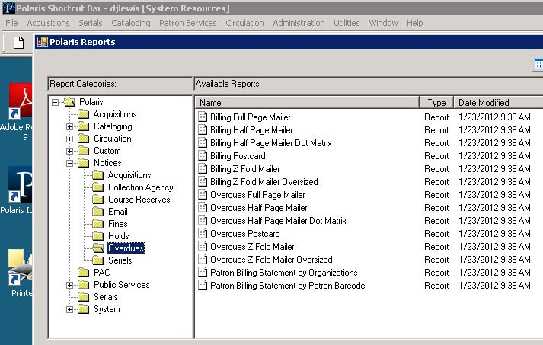

* Patrons will call to say they haven’t received notification of holds, overdues, almost overdue, etc. After we remind them that notices are a courtesy not guaranteed, ***we use an SQL query*** to find out when Polaris thinks they’ve been notified then track back to reports and logs to see if there’s any other useful information. For example, people who say they haven’t been called, but in the phone notification log there are 3-5 sec. calls indicated, with human voice and immediate hang up.

The magic SQL Query (thanks to Aaron Neslin)

SELECT NL.PatronID,nl.PatronBarcode,NL.NotificationDateTime, NT.Description,do.DeliveryOption, nl.DeliveryString,

Nt.Description,nl.Details, org.Name

FROM PolarisTransactions..NotificationLog NL WITH (nolock)

INNER JOIN

DeliveryOptions DO WITH (NOLOCK)

ON NL.DeliveryOptionID=DO.DeliveryOptionID

INNER JOIN NotificationStatuses NS WITh (NOLOCK)

ON NL.NotificationStatusID=ns.NotificationStatusID

INNER JOIN NotificationTypes NT WITh (NOLOCK)

ON NL.NotificationTypeID=NT.NotificationTypeID

Inner join Organizations ORG WITH (NOLOCK)

ON nl.ReportingOrgID=org.OrganizationID

WHERE PatronID =129281

ORDER BY NotificationDateTime desc

The resulting report:

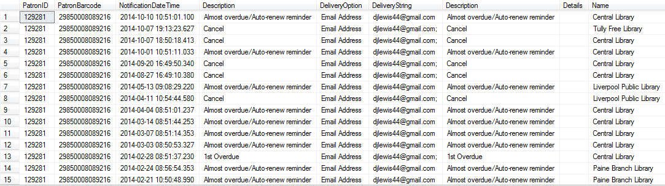

In the current version of Polaris, the fines notification history is available in the patron’s record or registration:

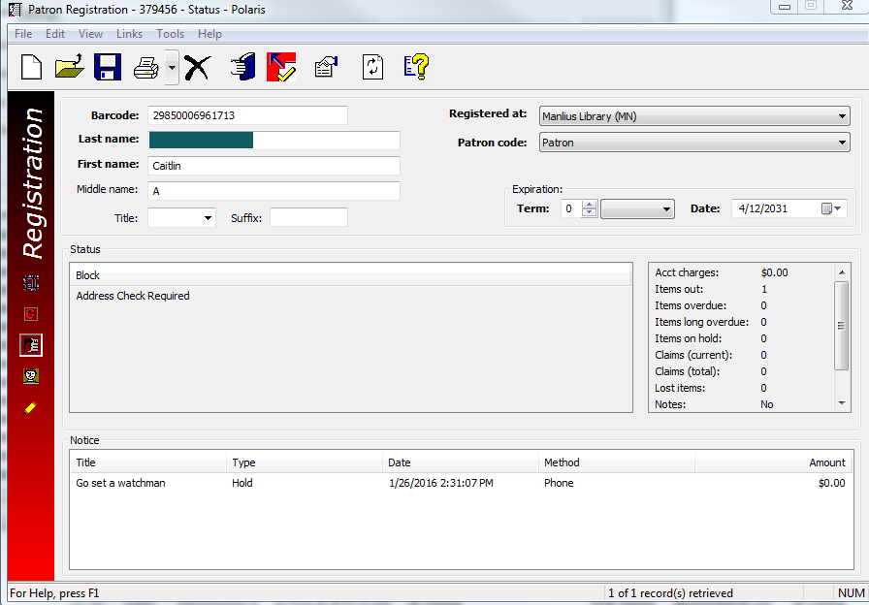

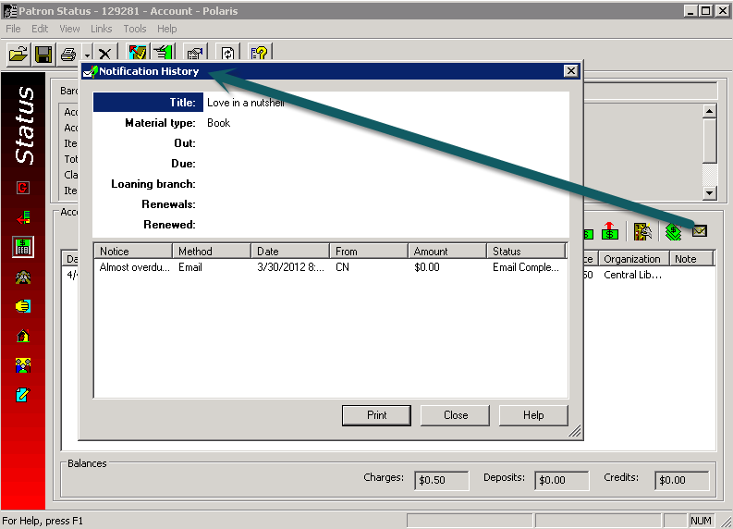

(So if you do run bill notices so long overdues can turn into lost materials but don’t print them, they’ll show up in the patron record as being sent.

**Resources**

* *Polaris® help file*

**Mailed Notifications**

**Detailed decisions**

* Which mailer format to use.
  + Did we retain fully-detailed, full-postage mailed notices? No – too costly for too slow notification, so we’d rather patrons choose a different notification method. Now using two different postcards, with address info on back (note: only two designs – holds and overdue):

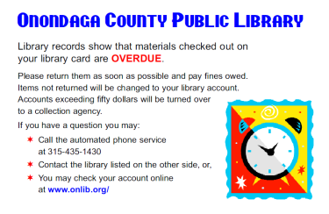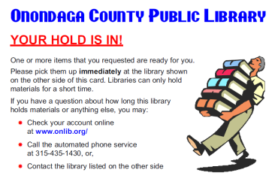

* What text to put on the mailer – especially if different policies within a consortium.
* How often do you mail them – and is it okay to skip weekends?
* Who mails them (e.g., centralized or each location, if a consortium)
* Who deals with returned mailers and the patron records – address verification needed
* Print them yourselves or have another company do so?

**Issues**

* Access – unlike other notification methods, you have to run and print these mailed notifications manually. On the Polaris toolbar, running notices is not permissioned separately from other toolbar-based reports. If notices are run by mistake and “posted” but not printed, those notices are lost and cannot be recovered easily[1]. We have libraries use the web-based Reports Manager instead of the toolbar for reports and hide access to the notices there.
* Use the right printer – for postcards, you need a printer that pushes them straight through, rather than around bends. If a few, you can actually just use the manual alternate tray feed on a regular printer. Many of those have a limit of <35 pieces, though. You’ll also need a sheet paper feeder if you’re going to do many postcards in a single batch. We use a Kyocera FS-4000DN 47 PPM Laser Printer w/Duplex, with the PF-315 2000 Sheet Paper Feeder, PT-310 Face Up Tray, and PB-315 Base Unit.

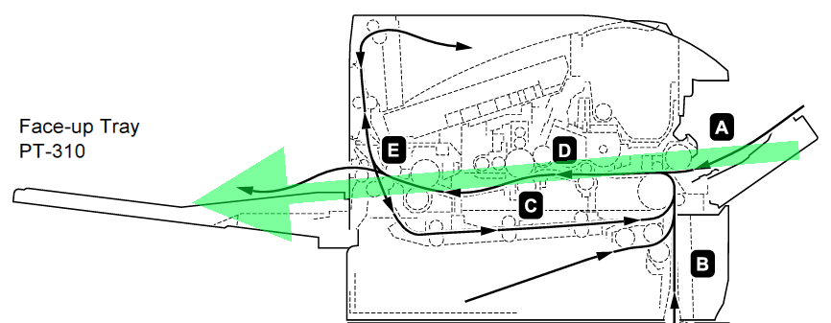 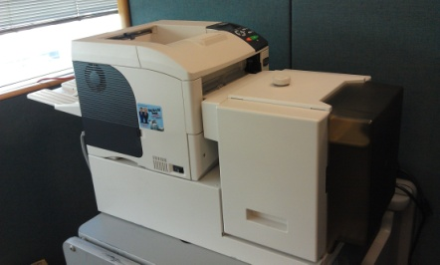

* Use paper stock of sufficient quality to avoid smeared ink. The post office will complain if you have unreadable addresses. We use 100# Accent opaque smooth text. The USPS has standards you have to follow for size and weight.

**E-Mailed Notifications**

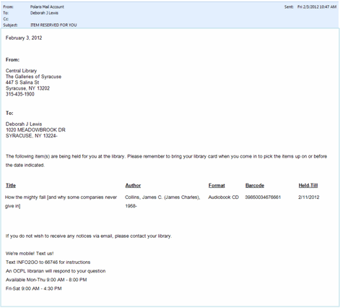 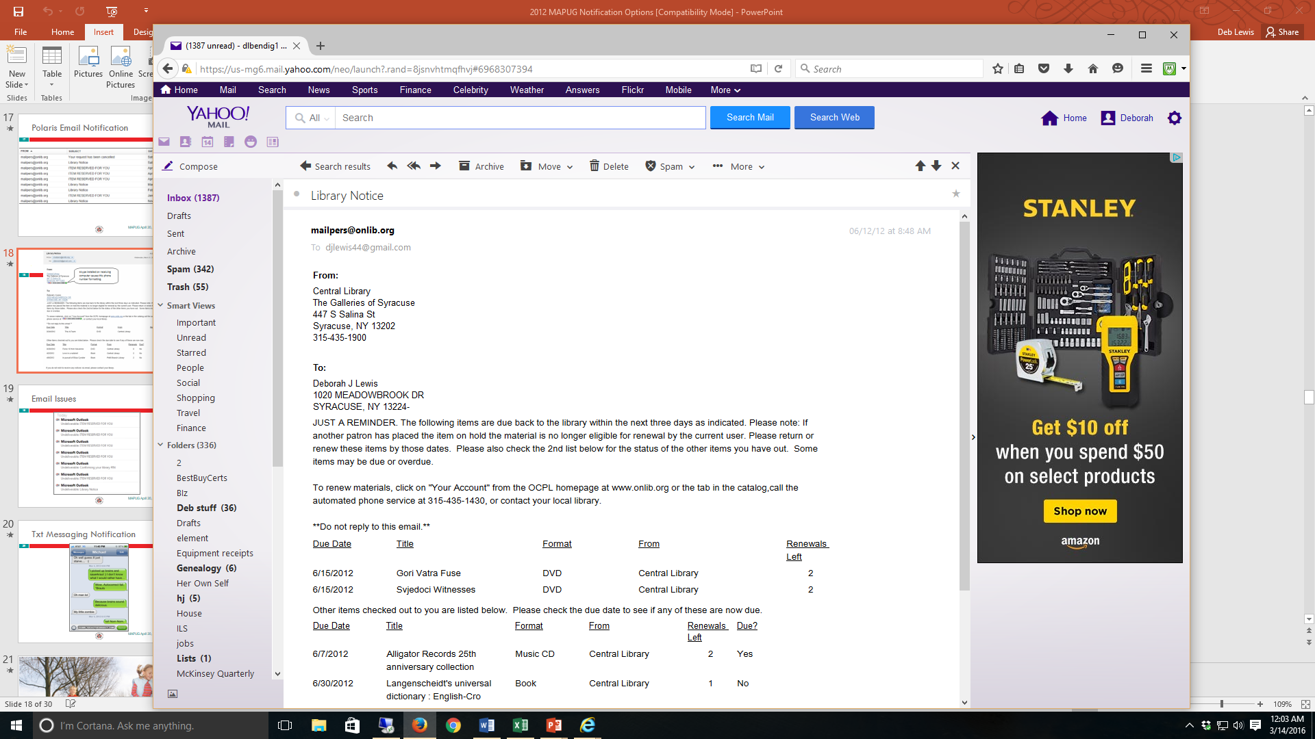

**Detailed decisions**

* Which notifications to send out via this method?
* What text to put in the email – especially if different policies within a consortium. Note: in Polaris 5.0, all notices editing is done via the Polaris Language Editor. Also note: you can put hypertext links into the email and patrons will see them if they have their email notices set to Full, HTML format.
* How often do you mail them, starting and stopping when, and on which days of the week? *Note*: SMS/txt messages are generated from the same job, so many libraries change their previous default 6:00 a.m. emailed notices to between 8:00 a.m. and 9:00 a.m. so their patrons won’t be disturbed too early with a txt message, although the new default is for this job to run every 4 hours between 9:00 a.m. and 8:00 p.m. Set your schedule in the SQL Management Studio – SQL Server Agent – Jobs – Notices Processing:

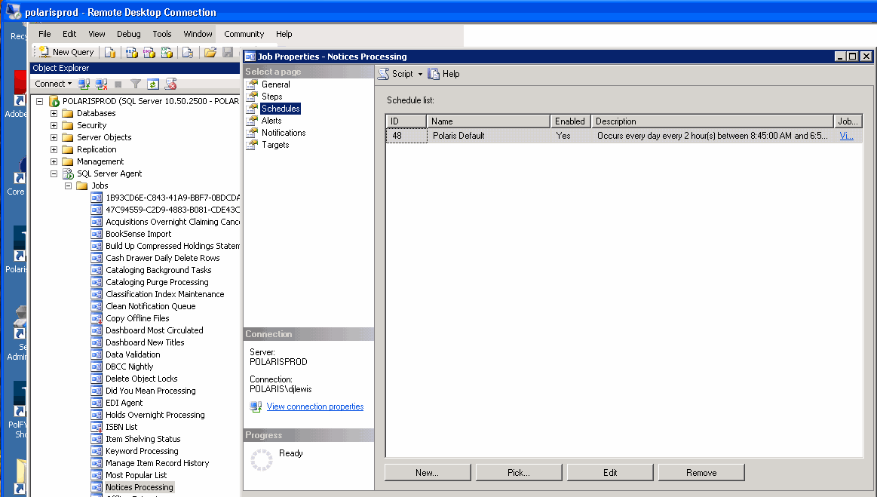

* From what email account are they mailed – we have a general one for the system
* Who deals with returned bounced emails and what to do about them. If centrally distributed, notify library involved about the bounce?
* You can have email notice success/failure reports automatically mailed to multiple people – does anyone actually want to receive them or use them?
* Bad characters in phone number fields can cause problems with text message notification. Staff needs to be careful

**Issues**

* Educational institutions (.edu) often have the tightest spam filters, so frequently reject emailed notices from the library. You can ask them to set the quota higher for your emails, but may not be successful as they may simply reject your notices regardless.
* Emailed notices go out in batches, particularly large ones at the beginning of the day. Many internet providers look at the number of emails received from the same source within a given time period, e.g., an hour, and will reject beyond that number as spam. You can sometimes ask them to set the quota higher for your emails, or fill out a whitelist request. In 4.0/4.1 Polaris allows you to slow down the rate at which notices are sent, but since most providers are checking number received per hour this doesn’t help.
* Have your patrons put your notices’ outgoing email address into their email contact list, which can act as an automatic whitelist with their email provider.
* Check the mail account for your outgoing email address for bounced emails. You can forward them back to the patrons to see if they’re also rejected as single email messages. Check for malformed email addresses and obvious typos.

If patrons contact the library saying they haven’t received an email notice when they should have, send them a test message from that account (and use that to suggest they put the address into their contacts). Sometimes patrons are just checking the PAC online for their holds, and saw that one was in before your notices job has run.

* You should check your status fairly often to be sure you haven’t been blacklisted. We use <http://www.mxtoolbox.com/blacklists.aspx> . If you’re blacklisted you then have to fill out a whitelist request or the equivalent with the agency who’s blacklisting you. And, blacklisting can cascade, so you need to handle it early.

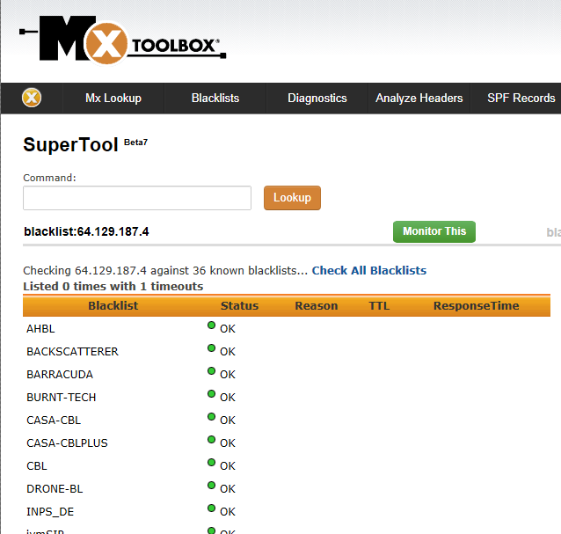

* Note from Polaris 4.1 documentation: “If an e-mail notice is sent but fails due to a poorly formatted e-mail address, or the recipient server rejected it, the failure is recorded in the notification log and the notice set to print instead. It is then posted with the rest of the printed notices when they are run. These failures are listed in the **Email delivery failure report** available from the Polaris Shortcut bar.”
* We have occasionally found cases where the email was rejected by the receiving service but doesn’t show up in failure reports. We generally only pursue when there’s a complaint. To look for these, check your reports manager server (ours is on PolarisWeb) **Windows Logs – System** for smtpsvc errors:

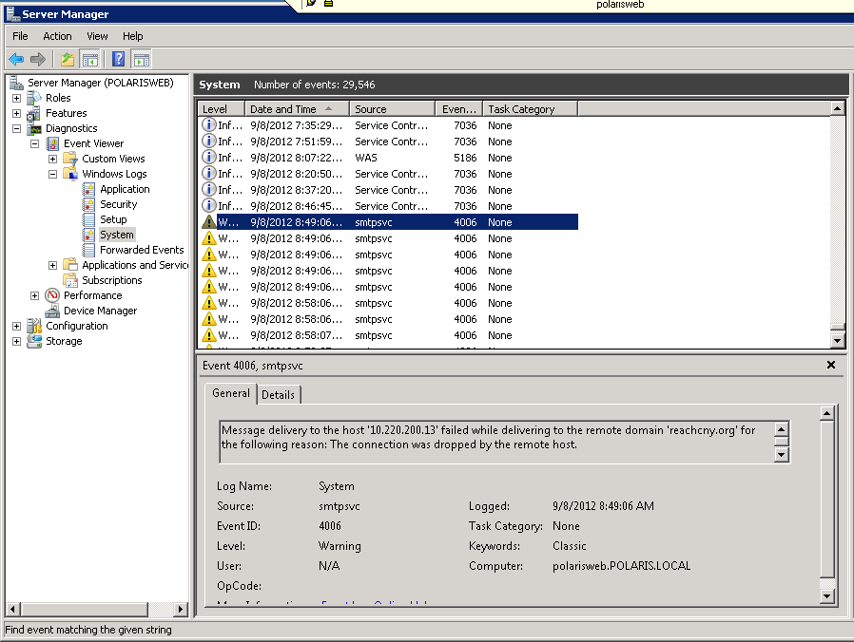

**SMS/TXT Messages**

*Note:* Txt messages going out from your Polaris are sent via email through the cellular service provider’s email-to-txt gateway, e.g., for Verizon cell phones, use *10DigitPhoneNumber@vtext.com.* **Even if you don’t provide Txt messages, some patrons may add this as their email address so they can receive txt message-based notices, but they won’t be formatted as txt messages.**

The patron’s mobile phone number must be identified as such in the patron record, and their carrier specified so that Polaris knows to match it with the email gateway to send it.

**Detailed decisions**

* Text of the txts – note limit of 160 characters; longer messages will be split and sent as multiple messages
* Allow txt as an additional notification method?
* How will you deal with bounces? Text message bounces are handled the same way as email bounces- Search by the phone number prefix on the (phonenumber)@sms/mms gateway, allowing for permutation in format (dashes may be present, not present, or irregular)
* How often do you mail them, starting and stopping when, and on which days of the week?  *Note*: txt messages are generated out of the same job as email notices, so many libraries change their 6:00 a.m. emailed notices to between 8:00 a.m. and 9:00 a.m. so their patrons won’t be disturbed too early with a txt message.

**Issues**

* SMS ([Short Message Service](https://en.wikipedia.org/wiki/Short_Message_Service) )/MMS (Multimedia Messaging Service) gateways can be difficult to find in the first place, and they can change. If not in the existing list in Polaris, or if those are failing:
  + Start on the service provider’s website
  + Search the web for sites listing gateways
* Cell phone providers much more difficult to reach than email or internet providers when they consider you to be a spammer.
* If the patron uses Verizon, there is a chance they have opted into a program that Verizon calls Block Premium Messaging. It is a way that Verizon customers can opt not to receive contest, weather alerts, purchase ringtones messages etc. Because of the way Polaris send out the messages, Verizon can interpret our messages as premium messages and blocks them as bulk messages.

**Telephony Notifications**

* Polaris Phone notification license outbound and inbound: Call$$ (we got 4 lines which incl. 4 Polaris staff access licenses). Annual software maintenance required.
* Requires a telephony server - somewhere
* Requires analog phone lines (**or analog converters if using digital/VoIP**)
* External service providers can do the notifications for you.

**Detailed decisions**

* How many lines, and how many of those for outbound notification and for inbound (phone attendant)
* Female vs. male voice – we started with male then switched as people were used to mostly females calling them from the library about their holds. Also deemed less threatening. What voice? Now 4 choices:
  + <http://www.robch.com/files/blogs.msdn.com/anna.wav>
  + <http://www.robch.com/files/blogs.msdn.com/mary.wav>
  + <http://www.robch.com/files/blogs.msdn.com/mike.wav>
  + <http://192.20.225.36/tts/speech/71d1c28c9e23264d5f219ae765cc9492.wav>
* Fully robovoice, or recorded parts, e.g., names of library/ies. We had those recorded by Vince Messina which is why we used a male voice to start. However, patrons felt a male voice was threatening after years of mostly older female volunteers/staff call them to leave messages about holds. You can get software free from Polaris that will guide you in recording the other parts of the messages if you want to. See the *Polaris Telephony Voice Recorder* manual in the Supportal for more information.
* Speed of the voice if robotic
* Script – ***very important***, as people are only partially listening, and potentially threatening words pop out. We removed all mention of going to collections for phoned overdue notices, and have shortened the scripts as much as possible.
* When to call – start and stop times and which days.

**Issues**

* The software is installed as services (attendant and notification) on the telephony server. Windows updates inevitably stop the services. Set them and their dependencies to automatic restart, but it still may not always work.

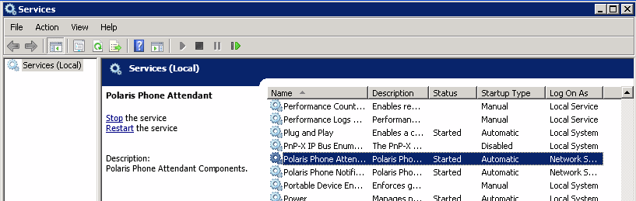

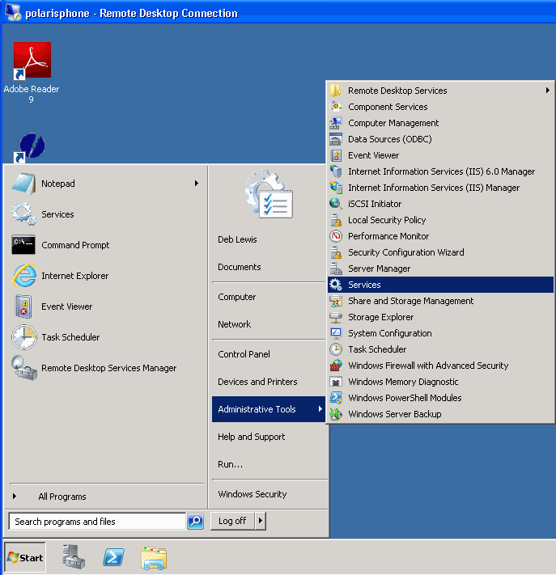

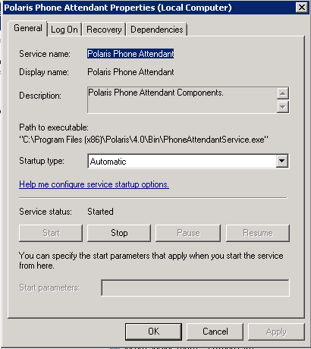

* There ***will be*** duplicate phone numbers in your patron file – usually old numbers not replaced or multiple people in the same household, so you will get calls from patrons saying they got a call but aren’t the person. They may or may not have heard or understood the patron name in the phone call. Search the patron file for the phone number to try to determine the actual issue:

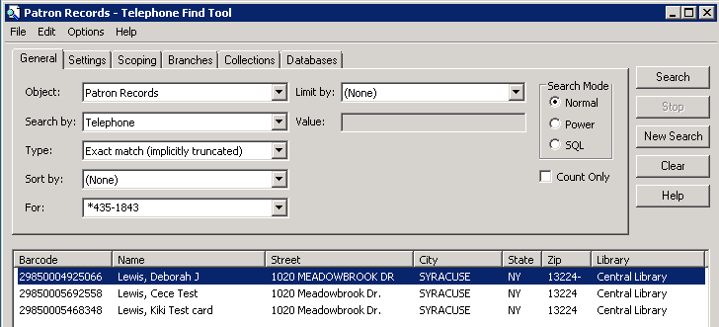

If there’s only one phone number listed, check the Phone Notification logs to be sure the call came from *your* telephony server. If not, ask them if they or another household member are a patron at another library. Try to find out exactly when this happened – but not likely. Note: we had a case where the patron was able to hear the name of the person being called. That person had a totally different phone number in their patron record but had apparently forwarded that number to the other patron’s phone [by mistake]. Impossible to figure out without an intended recipient’s name or the exact date and time of the call.

The phone logs on the telephony server are your friends. Note that bits and pieces of calls will be interspersed in the log – you can search for and/or follow patron id or phone number to see all of the call.

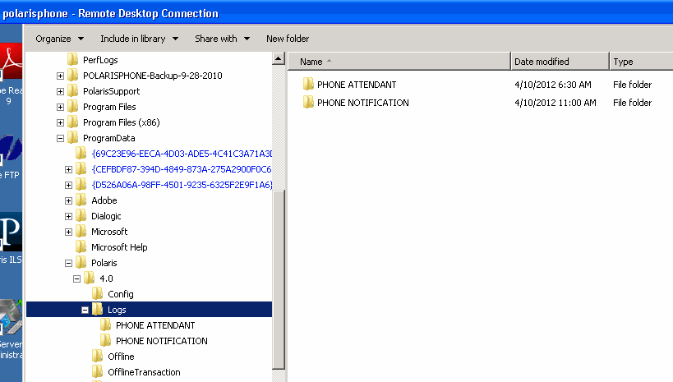

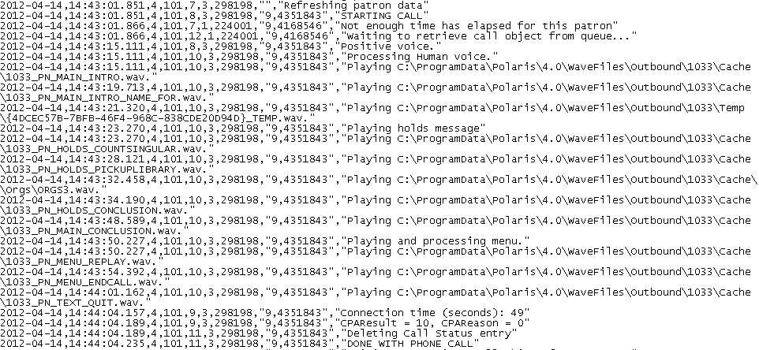

* Notifications build up in a queue during the time you’re not notifying people. After the queue is emptied each day telephony notifications can happen within a minute or two of checking in a hold, so sometimes people show up before you’ve put the hold on your holds shelf

1. ***From Customer Supportal:***

   **Problem**

   |  |
   | --- |
   | What should I do if notices are posted before printing has completed? |

   **Solution**

   |  |
   | --- |
   | After the notices are printed, a copy of the file is saved on the workstation at C:\Users\[user name]\Documents\My Reports. You can use this file to edit and reprint notices in case of printer or network problems. However, the file is overwritten each time notices are generated.  If you have already attempted to re-generate the notices and the file in your My Reports is empty, you can contact your Polaris Site Manager who will be able to provide you with an Excel spreadsheet of all patrons who had an overdue notice posted. Using the patron information provided in the spreadsheet, you will be able utilize the Patron Billing Statement by Patron Barcode report (found in the Reports and Notices utility in the Notices --> Overdues folder) to generate a print out of each patron’s outstanding charges.  For more information on the steps used to print notices, please refer to the “Print overdue, bill, fine, or request notices” Polaris help file. |

  