Idea Lab
IDEALAB.III.COM
What is it?  A place to view and post ideas that would make Sierra, Encore or other products we use better! Ideas then have an open forum to be discussed and voted on. Ideas that gain popularity are considered for development and inclusion in future releases.  Who is this for?  You! Library staff who use Sierra, Encore or other Innovative products now have a say in how the product evolves. We encourage you to raise your awareness of enhancements and help to promote ideas that help us to improve our services.  What do I do?  - Create an account  - Vote to support ideas that are good for your library.  We want to use this tool effectively and wisely, so we ask that we put forward ideas that have been vetted. If you think you have a great idea, reach out to us at Yourownsupportteam@yourlibrary.org and we will work with you to ensure the idea isn’t already available, coming soon or possibly not possible in our configuration.  More info?  Contact:  name  Organization  Title  Phone: ###-###-#### X ###  EMAIL: Yourownsupport@yourlibrary.org  Web Resources:  Idealab.iii.com |  | rEGISTER to Join the conversation  Everyone has the opportunity to help us to move good ideas forward. Please consider creating an account and be ready to add your support by “liking” the ideas we let you know about. We will be working with other consortia and public libraries to promote high priority items that benefit our needs.  Images are used to help “sell” the idea visually  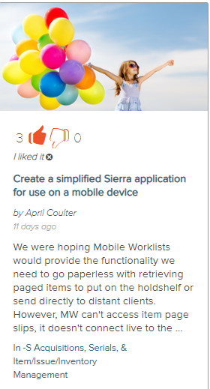  Vote count  Application / area  Contributor / Date  Description  Title / Task

How it works
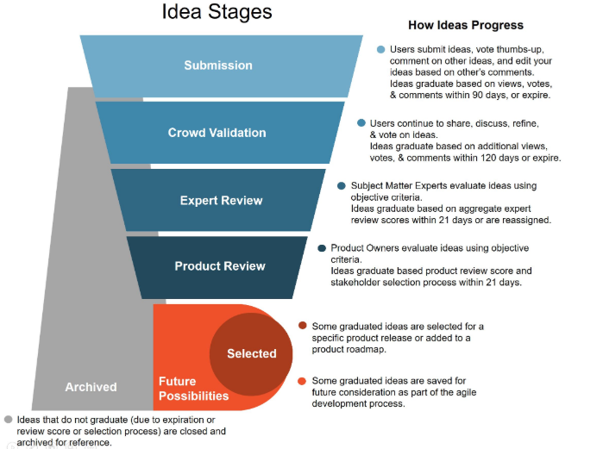

Always Open Space-Sierra
This is where ideas are shared. You can see and vote on Sierra, and products related to Sierra in this space.
How can you influence an idea?
Get Registered! Go to idealab.iii.com and get a login setup.

Get other staff registered! Share this information with everyone who might help us move an idea forward.

Get Ready! Mid-Hudson Library System staff will post links to new ideas to support in our Notices email group. All you need to do is follow the link and add your support, if you agree that it is a good idea. Library Directors can submit email addresses for staff who need to be added to the Notices email list by emailing techsupport@midhudson.org.
Crowd Validation ( or ) determines if in an idea advances. With each Mid-Hudson Library registered user in place, we have a great deal of influencing ability.

