IUG 2018, Session F02
Bulk Changes in Polaris : The Basics and Beyond. Supplementary document.
(Please see the PowerPoint presentation and accompanying notes for information on basic bulk changes.)
Affecting a bulk change using Authority Records
The instructions below go into greater detail than the PowerPoint slides.
Find the authority record you want to clean up (in this case, it is the third in the list).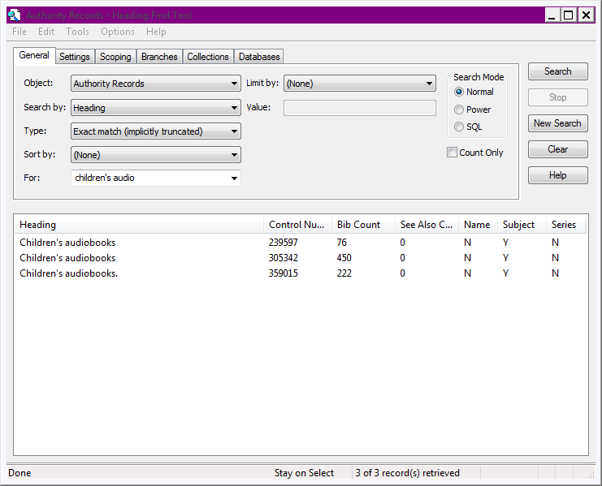
Open the record and choose Tools> Create Links to Bibliographic Records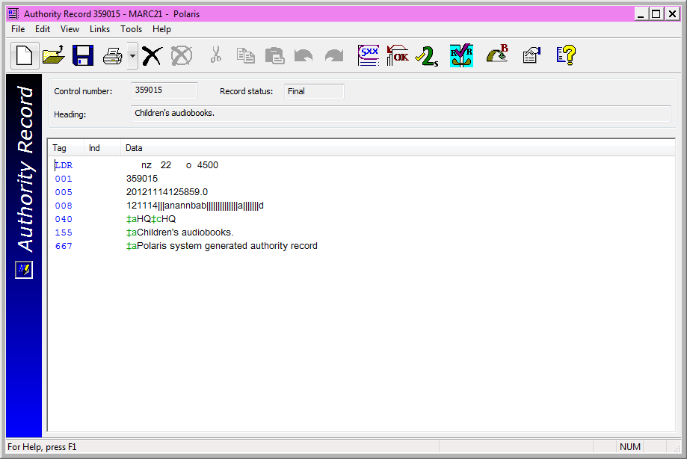

Select "stray" records to link. To select a long list, select the top heading in the list, scroll down to the bottom and then, while holding down the Shift key, select the bottom heading. All headings should now be highlighted.
Click the Link Selected button. This will put the link request into the Authority Create Links queue.
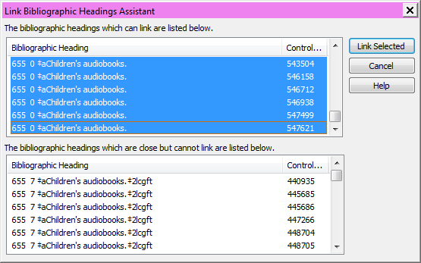
Wait for the linking job to be completed.
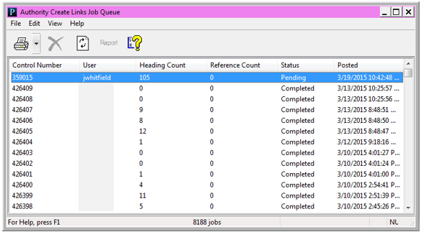

Check the authority record again to make sure that the Bib count is OK. (222+ 105 = 327, so we're good.)
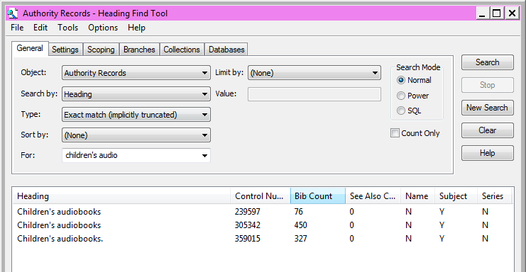
Open authority again and View > Linked bibliographic records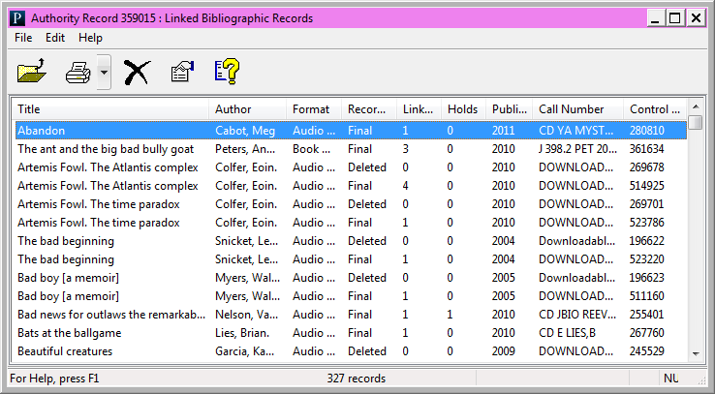
Select all the linked records and put them in a new record set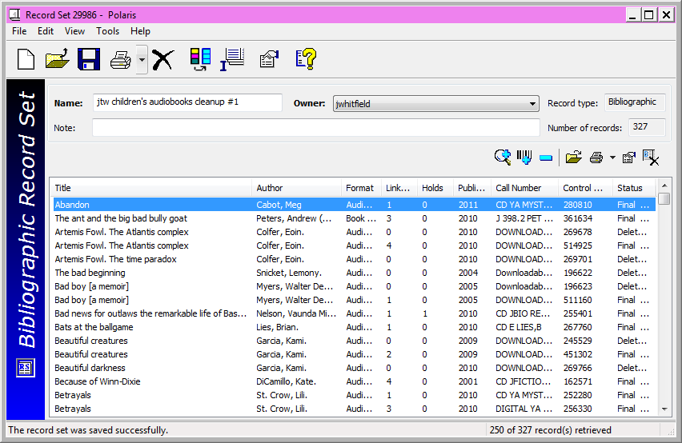
Remove any deleted bibs from the record set. (327–111=216.
If the heading (name, title, etc.) is in different MARC fields, separate your records into separate sets for each field.
If there are any records that should keep the heading, place them in a separate record set (in this case, there were none).
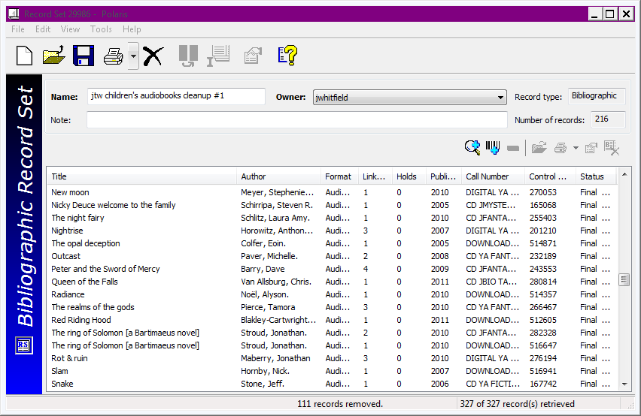
Delete the authority record and choose the option to Delete linked headings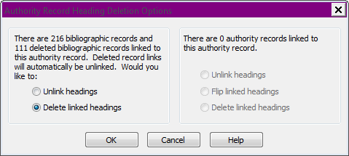

To check the records in the record set before adding the term, you can use this SQL query (replacing the highlighted information as appropriate)
SELECT BR.BibliographicRecordID
FROM polaris.Bibliographicrecords BR with (nolock)
join polaris.bibliographictags bt (nolock) on (br.bibliographicrecordid = bt.bibliographicrecordid)
join polaris.bibliographicsubfields bs (nolock) on (bt.bibliographictagid = bs.bibliographictagid)
WHERE
bt.tagnumber = 655
and bs.data like 'children% audiobooks'
and br.bibliographicrecordid in
(Select br.bibliographicrecordid
FROM polaris.Bibliographicrecords BR
JOIN polaris.BibrecordSets BRS (NOLOCK) ON BRS.BibliographicRecordID = BR.BibliographicrecordID
JOIN polaris.RecordSets RS (NOLOCK) ON RS.RecordSetID = BRS.RecordSetID
WHERE
RS.Recordsetid = 29987)
Remove these bibs from the record set (and save it, just in case).
From the record set, select the Bulk Change button and then choose the option to Insert a new tag. Make sure you select the tag number and indicators. To add subfields, start with $a (or whatever the first subfield should be). After entering the text, including any punctuation, click the Add button. This will add that subfield to the list below, but may not clear the data in the input boxes. Make sure you enter the appropriate subfield code as well as the text you want in the subfield. Click Add after each subfield is entered. Click Add Change to Queue when you are finished with the subfields. Lastly, click OK to submit the change.
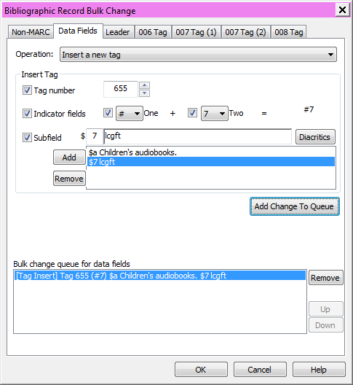
The change will take a few minutes. Check the Bibliographic Bulk Change queue and refresh as needed until the change has been completed.

If there was an existing Authority record the heading you just added should link to, check that record to make sure that the number of linked records looks good.
In this example, the procedure was repeated for each of the "extra" authority records in the initial list. (Three were combined into one.) The number of linked headings will not include any deleted records that were cleared in this process, so the initial numbers may not add up to the final number.
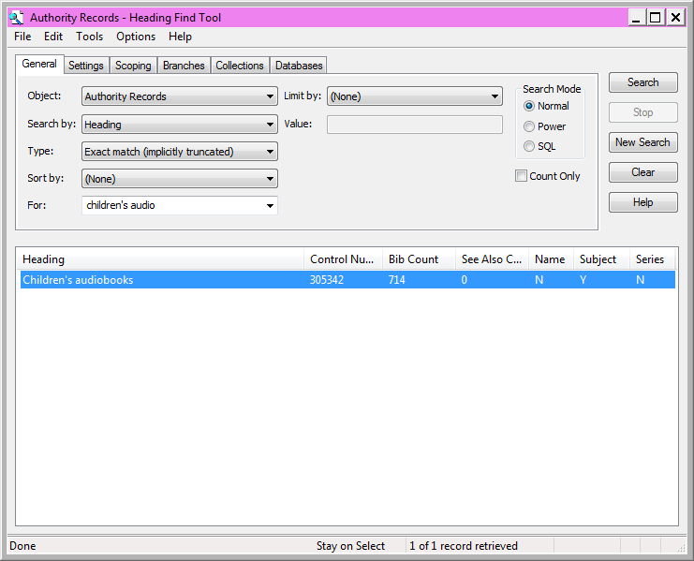
If there is not an authority record, but there should be one. Open one of the records with the heading and save it. You may be able to download an "official" authority record via ZMARC. If this does not work, you can create a local authority record for the heading.
Once you have downloaded or created an Authority record, It would be a good idea to open the Authority record and create links to Bibliographic records as needed.
If there are bibs that need to have the deleted authority, download a new copy or undelete the authority record and then use a bulk change on the appropriate record set to add the term back. Check to make sure the links were created (if not, manually create the links via the authority record).

Bulk changing by Exporting, Editing and Re-importing
(If you have Export Express, you can skip down to step 6 below.)
- If you do not have Export Express, bulk add an easily-identifiable field to all the records you wish to export. This marks those records as having been changed.
- Go to The Utilities menu and select Exporting.
- Use the Tools menu to select the desired location for the export file and report.
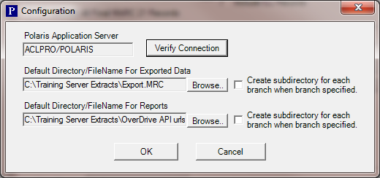
Choose the option to Extract Only MARC21 Records Added / Changed from Date:
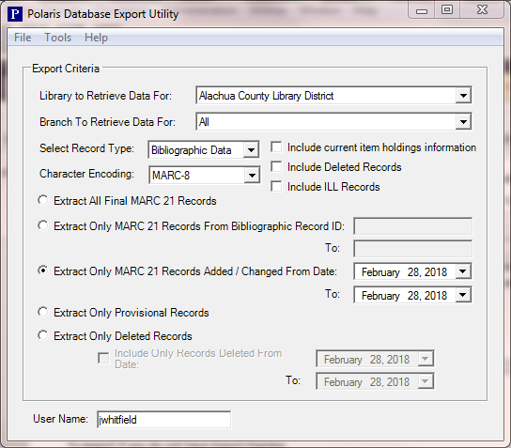
- The file of records may contain additional records that were added or modified that day. Use your chosen editing application to split the file or weed out any records that do not contain the field you added above.
- Use your chosen editing application to make bulk changes as desired.
- Import the records into Polaris. Choose whether you want to replace the existing records, or insert data from the incoming records to the existing Polaris records*. To force a match with existing records, you can copy the number from the 001 field to an 035 field in your exported records and choose the option to match the incoming 035 to existing 001 (Polaris 6.0 should support matching 001 to 001, so this may not be necessary).
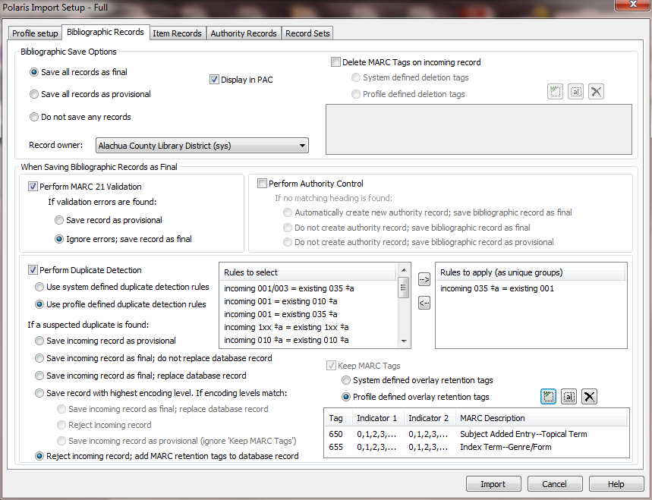
*IMPORTANT: If you intend to replace existing fields with modified data via the Reject/add MARC retention tags option, use bulk changes to delete all instances of those fields in your Polaris records before you import. If not, you will end up with both the "good" and "bad" forms of those fields in your records! (If this happens, you can delete all instances of the fields and import the records again.)

Converting Data into MARC and Importing to Add Fields (or Replace Deleted Fields)
To do this, you will need a list of the matching fields (I recommend the control number/BibliographicRecordID) along with additional information, such as the Browse Title, and perhaps the information you want to change (if you are want to replace existing data).
You may want to place your "records" in a spreadsheet to make editing easier if you are going to customize the data to be added (see column K in the example below). The example on the next page is used to illustrate the concept. It is not formatted according to a specific conversion application's requirements and may not include all of the data needed for conversion. (Use the instructions for your application to format the spreadsheet data and/or text as needed.)
In this example the CTL number has been copied to the 035No column. If you have any data with leading zeroes, make sure to format those cells (columns, rows) as text, otherwise those zeroes will be stripped out.
(As mentioned above, with Polaris 6.0 you may not need to copy the control number to an 035, but you will (probably) need to add 001 tag information before the control number.)
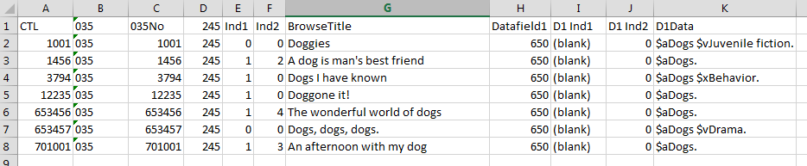
If you use a spreadsheet, it is likely you will need to convert your data to text and make global changes using a word-processing application to put the data in a format that can be converted into MARC.
***Beware of autocorrecting features that may turn quotes into "smart quotes," replace double hyphens with M-dashes, etc..
Once the data has been converted into MARC, import the records using the option to reject the incoming record and add MARC retention tags to the database record.

