Leap Forum Notes
Facilitated by Kellie Conner, kellie.conner@iii.com
Notes by Jen Ferriss, jferriss@sals.edu

Remember to use the forums and the supportal
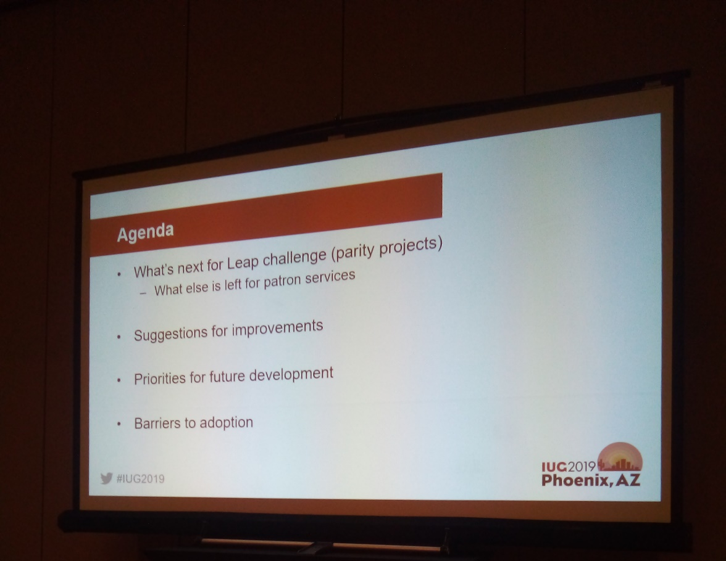

Need to prioritize the Next Leap Challenge submissions

- Item templates – people in the room seemed to want this one but then may have changed their mind after a discussion about finishing circulation, then move on to cataloging
Patron bulk changes
- Very few use Course Reserves
- Borrow by Mail “easy” – KC
- Outreach “bigger” but working to get this in- KC
  - Outreach is on the 6.4 Roadmap (end of 2019) – it is what Leap is great for!
- Manual billing
- End of Term Due Dates
- Quick bib low on the list (for group that attended)

Items that did not make the challenge
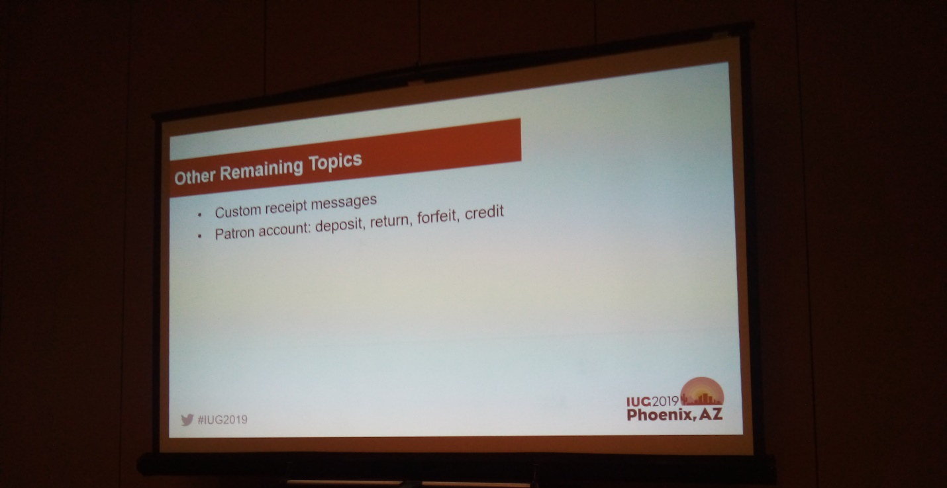
- Do we need custom receipt messages in Leap? (I didn’t write down an answer – JF)
- Do we need Deposit, return, etc…? This is mainly for room deposits and not paying from a credit for fines and fees. Some use this.
Priorities for future Development:
If you have a smaller library where all the work is done at one desk, Leap will need more functionality; if you have more staff, then you just need patron interaction functionality
Q: Can we add more credit card companies?
A: Credit Card payments need to be through Comprise or Envisionware due to PCI compliance
Some ideas for future development:
- Bib record creation
- Labels
- Closed date table (venturing into System Admin) to create defined hours of operations
- Add a note at check in when resolving charges – right now you have to finish the transaction and then back track to the patron record and add a note
- Printing is still an issue – not all people want to move to e-receipt (or can do to access) Sending to the printer is too many steps.
  - There is a way to set this up in Chrome to print on demand, but everything you print using Chrome would go to the receipt printer
  - It was mentioned that there are web based APIs that would work with the browsers and specific printers
  - Most in the room used Star or Epson printers
Note: Talk to Sean Hill if you want more info
- Permission issues – if you have Outreach you can see all reading history
  - Check out the IDEA LAB – comment and thumbs up or down
We limit who can see patron reading history in the system for privacy reasons. Only our staff performing outreach tasks are given permission to view reading histories, but they can see the reading history of both outreach patrons and all patrons that have chosen to maintain their reading history.
We recommend an admin setting be added giving the choice whether Patron Reading History access applies only to outreach services patrons, or all patrons. Alternatively, a new permission could be created only giving access to patron reading history for outreach patrons. In both cases it may be required to move the Outreach Services selection field to a different page in the tool.
- Phone via cell phone (not Telephony) can we relabel notification options?
- It appears that texting requires different formats for different providers – how do we deal with that? Data validation by carrier
- “Patron mode” on registration so you can flip the screen around and have them fill out their registration with out seeing extra information on the screen. It would lock them into certain fields. Or improve Power Pac registration
- Find Tool issues: Default sort, newest at the bottom since it sorts by control number. Can we have granular user defined defaults?
  - Relevance and popular sorts
  - User default with filters
  - Add the article table
  - Search other databases for ILL (Z39.50 or the like and then be able to “save” the bibliographic record in the future - JF)
- Select all or select some. Need to add to a record set to do this now
- KC is hoping to change the find tool into a workform in order to have multiple tools open
- Sort is gone when you using the pick list and you say you have located an item (sticky or lock the list)
- Secure patron feature – staying as is because it was developed for a customer
- Object locks are an issue
  - Reminder to exit properly
  - Re-add replace job that runs overnight
  - You can run right before your back up (add it to the change job list)
- Ability to see notes in request manager – you need this for INN-REACH
  - You can see the note in the find tool
  - Request manager has a real estate issue
  - iPad is the lowest common denominator
  - INN-REACH users should get consensus and put request in the Idea Lab
Open questions/conversations
Q: How do you get buy in on using Leap?
As: Take away Polaris so they need to learn Leap
Top down
Hold them accountable
Start with iPads (Kindle Fires are not supported and have some errors, but do work)
Have a Leap day (ex. Wednesdays we just use Leap)
Show them the benefits
New people love Leap – it is harder for people used to using the Staff Client to switch
Call it a new upgrade and then take away Polaris
Use statistics to make the case and show who is not using Leap
See how many machines logged in

Misc:
Firefox is not supported
Tablets can’t be a workstation
Can you suppress autofill forms in browsers? Or can iii fix fields to not recognize?
Being incognito is not supported
Action for Jen Pelton
Create a place on the forums for sharing Leap Training Materials

