**SQL Searching in the Find Tool: Supplementary Document**

**Translations from a Normal Search (what Polaris calls IDs in a Normal search)**

BibliographicRecordID = Control Number (Bibliographic Records)

ItemRecordID = Control Number (Item Records)

PatronID = Record ID (Patron Records, Patron Registration)

RecordSetID = Record Set ID (Record Sets)

InvoiceID = Invoice ID (Invoices)

POLineItemID = PO Line ID (Purchase Order Line Items)

(Some Find Tools do not include an ID option. Purchase Orders, for example have an External ID, but this is not the same as a PurchaseOrderID.)

**Sample Joins:**The pattern is …FROM Table1 with (nolock) JOIN Table2 (nolock) ON (Table1.Field = Table2.Field)

or, to use the first row of the samples:

…FROM BibliographicSubfields bis with (nolock) JOIN BibliographicTags bit (nolock)  
ON (bis.BibliographicTagID = bit.BibliographicTagID)

|  |  |  |  |  |
| --- | --- | --- | --- | --- |
| **Table1** | **Field** | **=** | **Field** | **Table2** |
| BibliographicSubfields | BibliographicTagID |  | BibliographicTagID | BibliographicTags |
| BibliographicTags | BibliographicRecordID |  | BibliographicRecordid | BibliographicRecords |
| CircItemRecords | AssociatedBibRecordID |  | BibliographicRecordID | BibliographicRecords |
| CircItemRecords | ItemRecordID |  | ItemRecordID | ItemRecordDetails |
| InvLineItemSegments | InvLineItemID |  | InvLineItemID | InvLines |
| InvLineItemSegments | InvoiceID |  | InvoiceID | Invoices |
| InvLineItemSegments | POLineItemSegmentID |  | POLineItemSegmentID | POLineItemSegments |
| InvLines | InvoiceID |  | InvoiceID | Invoices |
| InvLines | POLineItemID |  | PoLineItemID | PoLines/  POLineItemSegments |
| ItemRecordHistory | ItemRecordID |  | ItemRecordID | CircItemRecords/  ItemRecordDetails |
| ItemRecordHistory | PatronID |  | PatronID | Patrons/  PatronRegistration |
| Patrons | PatronID |  | PatronID | PatronRegistration |
| POLineItemSegments | POLineItemID |  | POLineItemID | POLines |
| POLineItemSegments | PurchaseOrderID |  | PurchaseOrderID | PurchaseOrders |
| POLines | BibliographicRecordID |  | BibliographicRecordID | BibliographicRecords |
| POLines | PurchaseOrderID |  | PurchaseOrderID | PurchaseOrders |
| SysHoldRequests | BibliographicRecordID |  | BibliographicRecordID | BibliographicRecords |
| SysHoldRequests | PatronID |  | PatronID | Patrons/  PatronRegistration |

**Date Fields in Polaris and Definitions** *(Definitions are from the Database Repository, or help file, with some minor tweaks. More information on the Repository is on the last page of this document.)*

Note: Some dates have identical names, for example CreationDate, but these are not always consistent. (Patron records use EntryDate.)

Also, some dates may duplicate those in higher levels (PO Lines and Purchase orders, for example) but this may not always be the case, so it is important to determine which level for which you need a date.

**Item Records: Tables: CircItemRecords, ItemRecordDetails. View: ItemRecords**

AcquisitionDate The Item record creation date. Populated only if item is linked to Acquisitions.

CheckInDate The date the item was last checked in

CreationDate The date that the item record was created

FirstAvailableDate The date the item was first available in Polaris

ImportedDate The date when the record was entered into the system (import or original cataloging)

InTransitRecvdDate The date the in-transit item was received

InTransitSentDate The date the item was sent in-transit

ItemStatusDate The date the item status last changed (circulation status)

LastCheckOutRenewDate The date the item was last checked out or renewed

LastCircTransactionDate The date when the item was last circulated

LastDueDate The item's due date when item was last checked out or renewed

LastInventoryDate The date when the item was last inventoried

ModificationDate The date when the record is updated (modification can happen by individual change, bulk change, or by bulk processes).

OriginalCheckoutDate If item's status is Lost or Claimed, this is its original checked out date.

OriginalDueDate If item's status is Lost or Claimed, this is its original due date.

RecordStatusDate The date when the record's status was last changed. either from Provisional, Final or Deleted.

**Bibliographic Records: Table: BibliographicRecords**

BoundWithCreationDate Creation date of the Bound-With link

CreationDate Non-MARC creation date. The date the record was added to Polaris. With imported records, this may be different from the MARCCreationDate.

FirstAvailableDate The first available date for the bib is the first day the first item linked to the bib becomes available for circulation.

ImportedDate For an imported record, this is the date on which the record was imported.

MARCCreationDate This data is pulled from tag 008/00-06 during the indexing process.

MARCModificationDate This data is pulled from tag 005 during the indexing process.

ModificationDate Non-MARC modification date. (This includes modifications that are not associated with the MARC record, such as the DisplayInPAC field.

RecordStatusDate The date when the record's status was last changed. either from Provisional, Final or Deleted.

**PatronRecords: Tables: Patrons, PatronRegistration**

EntryDate The date when the record is inserted.

ExpirationDate The date when the patron's registration expires.

AddrCheckDate The date to check patron address

UpdateDate The date when the patron registration is modified.

Birthdate Patron's birth date

RegistrationDate The date when the patron gets registered.

LastActivityDate The date of last circulation activity.

SDIPositiveAssentDate The date that assent was changed.

MergeDate The date this patron was merged with another

RecordStatusDate For future use. (The date when the record's status was last changed. either from Provisional (?), Final or Deleted)

**Purchase Orders: Table: PurchaseOrders**

EDIFileCreateDateTime System generated date & time that a BISAC file for this order was created.

CreationDate System generated date & time when the record was created.

ModificationDate System generated date & time the record was last modified.

MembershipRenewalDate The date on which a membership is due for renewal.

POConfirmDate The date upon which the library received confirmation from a supplier/vendor that the order had been received.

ReleaseDate Date that purchase order was released on.

RentalReturnDate Return date for any rented materials.

ShipDate Instructions to the supplier about the earliest date an order is to be shipped.

StatusDate The date on which the purchase order status was entered.

**PO Lines: Table: POLines**

ClmAlertDate The date on which the item should first appear on the Claim Alert List.

CreationDate System generated date & time that this record was created.

ModificationDate System generated date & time of the last modification to this record.

POConfirmDate The date upon which the library received confirmation from a supplier/vendor that the order had been received.

RentalReturnDate Return date for any rented materials.

StartDate The date on which a subscription, standing order, approval plan or other continuing plan should start.

SubscrExpDate The date on which a subscription is due to expire.

StatusDate The date on which the current acquisitions status was entered.

**PO Line Segments**: **Table: POLineItemSegments**

CreationDate System generated date & time that this record was created.

ModificationDate System generated date & time of the last modification to this record.

PaymentStatusDate The date on which the current payment status was entered.

StatusDate The date on which the current acquisitions status was entered.

**Invoices: Table: Invoices**

CheckDate The date that appears on a printed check.

CreationDate System generated date & time that this record was created.

InvClosingAlertDate The date on which the system should alert the user that an invoice should be closed.

InvDate The supplier-assigned invoice date.

InvReceiptDate The date on which an invoice was received at the library.

ModificationDate System generated date & time of the last modification to this record.

PaymentDueDate Entered by a user or calculated using 'number of days due' dependent upon the payment terms option.

PaymentTerms Describes the date at which payment of the invoice is due, can be enter as 'number of days' or a specific date.

ShippedDate Date that the supplier says item(s) were shipped.

VchrDate The date that appears on a printed voucher.

InvStatusDate System supplied date & time the InvoiceStatusID was set.

**Invoice Lines: Table: InvLines**

CreationDate System generated date & time that this record was created.

ModificationDate System generated date & time of the last modification to this record.

ShippedDate Date that the supplier says item(s) were shipped.

StartDate The date on which a subscription, standing order, approval plan or other continuing plan should start.

SubscrExpDate The date on which a subscription is due to expire.

CheckDate The date that appears on a printed check.

VchrDate The date that appears on a printed voucher.

PaymentStatusDate The date on which the current payment status was entered.

**Invoice Line Segments: Table: InvLineItemSetments**

CheckDate The date that appears on a printed check.

CreationDate System generated date & time that this record was created.

ModificationDate System generated date & time of the last modification to this record.

PaymentStatusDate The date on which the current payment status was entered.

VchrDate The date that appears on a printed voucher.

**Holds: Table: SysHoldRequests**

CreationDate Date the hold request was placed.

ActivationDate Date the hold request is activated (system does not attempt to satisfy request until after specified date has been reached). Optional.

ExpirationDate Date the hold request expires.

LastStatusTransitionDate Date of last status transition.

HoldTillDate Number of days an item would be held for a patron.

ModificationDate Date when the hold request was last modified.

HoldNotificationDate Denotes the date when a notice for this request was sent.

HoldNotification2ndDate Denotes the date when a second notice for this request was sent.

PrimaryRTFBeginDate Date primary RTF cycles begin.

PrimaryRTFEndDate Date primary RTF cycles end.

SecondaryRTFBeginDate Date secondary RTF cycles begin.

SecondaryRTFEndDate Date secondary RTF cycles end.

**Searching for classes of characters in text strings.**

[A-Z] means any single alphabetic character (case and diacritics are not considered).

[0-9] means any single numeral.

[ABCE] means a single A, B, C or E in a text string.

WHERE BrowseCallNo like '[A-Z][A-Z][A-Z]%' means the bibliographic record's call number starts with any three alphabetic characters.

Another example: WHERE BrowseTitle like '[0-9] days on a raft' will find any single number followed by the string.

(If you need to include an actual set of brackets in your text string, precede the brackets with a backslash “\”. This tells the query that you are literally searching for a bracket, instead of starting a class of characters.)

**Case-sensitive searching for strings**.

COLLATE is used to make a string case-sensitive.The syntax for COLLATE is: COLLATE Latin1_General_CS_AS_KS_WS or COLLATE Latin1_General_BIN (or BIN2)

C = case  
A = accent  
K = kanatype (to do with Japanese characters, not usually an issue, cn be omitted)  
W = width (single-byte vs double-byte character, not usually an issue, so can be omitted)

_I = …insensitive  
_S = …sensitive  
SC = supplementary characters

select bibliographicrecordid from bibliographicrecords with (nolock)

where

browsetitle COLLATE Latin1_General_CS_AS like 'FB%' (works with a text string)

browsetitle LIKE '[A-Z][A-Z][A-Z]%' COLLATE Latin1_General_BIN (works with a regular expression)

**Sample Queries for the Find Tool**

**--Sample queries from the presentation:**

**ITEM RECORDS THAT WERE RENEWED (OR AUTO-RENEWED) AT A PARTICULAR BRANCH OVER THE COURSE OF TWO DAYS**

SELECT ItemRecordID from ItemRecordHistory with (nolock)

WHERE ActionTakenID IN (73,74,76,80,82,93)

AND TransactionDate BETWEEN '01/14/2018' and '01/15/2018 23:59:59.999'

AND OrganizationID = 7

**FINAL BIBLIOGRAPHICRECORDS WITH COLOR INFORMATION SPELLED "COLOUR" IN THEIR 300 FIELD.**

SELECT br.BibliographicRecordID from BibliographicRecords br with (nolock)

JOIN BibliographicTags bt (nolock)

ON (br.BibliographicRecordID = bt.BibliographicRecordID)

JOIN BibliographicSubfields bs (nolock)

ON (bt.BibliographicTagID = bs.BibliographicTagID)

WHERE

br.RecordStatusID = 1

AND bt.Tagnumber = 300

AND bs.Data like '%colour%'

**DELETED BIBLIOGRAPHIC RECORDS WITH AN AUTHOR'S SURNAME OF ADAMS**

SELECT BibliographicRecordID from BibliographicRecords with (nolock)

WHERE

RecordStatusID = 4

AND BrowseAuthor like 'Adams,%'

**PURCHASE ORDER LINES FOR A SPECIFIC BRANCH'S ORDERS**

SELECT POLineItemID from POLineItemSegments with (nolock)

WHERE

DestinationOrgID = 15

**PATRON(S) WHO MAY HAVE BILLS ON THEIR ACCOUNT FOR A DELETED AND PURGED ITEM**

SELECT pa.PatronID from PatronAccount pa with (nolock)

JOIN PatronAcctDeletedItemRecords pad (nolock)

ON (pa.ItemRecordID = pad.ItemRecordID)

where pad.Barcode like '32054123456789'

**--Additional queries that may be helpful.**

**Data to replace for your own queries are highlighted in yellow. Other criteria can be modified as needed.**

**TWO QUERIES DESIGNED TO EXCLUDE RECORDS (AND WHY THEY GAVE DIFFERENT RESULTS)**

This query looks for Bibliographic records that have linked items in a specific Collection, but that are not assigned to two branches. The result when I ran it on our database was 672 records.

SELECT AssociatedBibRecordID FROM CircItemRecords with (nolock)

WHERE AssignedCollectionID = 19

AND AssignedBranchID not in (4,5)

This query appears equivalent to the one above at first glance, but it retrieved 609 records.

SELECT AssociatedBibRecordID FROM CircItemRecords with (nolock)

WHERE AssignedCollectionID = 19

EXCEPT

SELECT AssociatedBibRecordID FROM CircItemRecords with (nolock)

WHERE AssignedBranchID in (4,5)

The difference occurred because the first query found Bibliographic records where at least one linked item was assigned to a branch other than 4 or 5, but it also found Bibliographic records that had another linked item that was assigned to 4 or 5.  
The second query excluded Bibliographic records that had any linked item assigned to 4 or 5, resulting in the smaller number.

**BIBLIOGRAPHIC RECORDS WITH ON ORDER CALL NUMBER, ITEMS IN PROCESSING AND 10 OR MORE HOLDS**

SELECT distinct br. bibliographicrecordid FROM bibliographicrecords br with (nolock)

JOIN rwriter_bibderiveddataview rw (nolock) ON (br.bibliographicrecordid = rw.bibliographicrecordid)

JOIN itemrecords it (nolock) ON (br.bibliographicrecordid = it.associatedbibrecordid)

WHERE

br.browsecallno like 'ON ORDER%'

AND it.itemstatusid = 15

AND rw.numberactiveholds >= 10

**BIBLIOGRAPHIC RECORDS CREATED BY A USER (searching by Name, rather than ID) AFTER A SPECIFIC DATE**

SELECT br.bibliographicrecordid FROM bibliographicrecords br with (nolock)

JOIN polarisusers polu (nolock) ON (br.creatorid = polu.polarisuserid)

WHERE br.creationdate >= '02/01/2018'

AND br.recordstatusid = 1

AND polu.name like 'jwhitfield'

**BIBLIOGRAPHIC RECORDS IN A RECORD SET THAT DO NOT HAVE AN OCLC NUMBER**

SELECT br.bibliographicrecordid FROM bibliographicrecords br with (nolock)

JOIN BibrecordSets BRS (NOLOCK) ON BRS.BibliographicRecordID = BR.BibliographicrecordID

JOIN RecordSets RS (NOLOCK) ON RS.RecordSetID = BRS.RecordSetID

WHERE

RS.RecordSetID = 11111 AND

BR.BibliographicrecordID not in

(SELECT BR.BibliographicRecordID AS recordID

FROM Bibliographicrecords BR

JOIN BibrecordSets BRS (NOLOCK) ON BRS.BibliographicRecordID = BR.BibliographicrecordID

JOIN BibliographicTags BT (NOLOCK) ON BT.BibliographicrecordID = BR.BibliographicrecordID

JOIN BibliographicSubfields BS (NOLOCK) ON BS.BibliographictagID = BT.BibliographicTagID

JOIN RecordSets RS (NOLOCK)

ON (RS.RecordSetID = BRS.RecordSetID)

WHERE

RS.RecordSetID = 11111 AND

BT.TagNumber = '035'

AND BS.Subfield LIKE 'a'

AND Data LIKE '(OCoLC)%')

**BIBLIOGRAPHIC RECORDS IN A RECORD SET THAT HAVE A PARTICULAR STRING IN A MARC FIELD**

SELECT br.BibliographicrecordID FROM Bibliographicrecords br with (nolock)

INNER JOIN BibliographicTags bt with (nolock)

ON (bt.bibliographicrecordID = br.BibliographicrecordID)

INNER JOIN Bibliographicsubfields bs with (nolock)

ON (bt.bibliographictagID = bs.bibliographictagID)

WHERE

bt.tagnumber = 655

AND bs.data like 'thrillers%'

AND br.bibliographicrecordid in

(SELECT br.bibliographicrecordid FROM bibliographicrecords br with (nolock)

JOIN bibrecordsets brs (nolock) ON (brs.bibliographicrecordid = br.bibliographicrecordid)

JOIN recordsets rs (nolock) ON (rs.recordsetid = brs.recordsetid)

WHERE rs.recordsetid = 30522)

**BIBLIOGRAPHIC RECORDS IN A RECORD SET THAT DO NOT HAVE A PARTICULAR STRING IN A MARC FIELD**

SELECT br.bibliographicrecordid FROM bibliographicrecords br with (nolock)

JOIN bibrecordsets brs (nolock) ON (brs.bibliographicrecordid = br.bibliographicrecordid)

JOIN recordsets rs (nolock) ON (rs.recordsetid = brs.recordsetid)

WHERE rs.recordsetid = 33514

EXCEPT

SELECT br.BibliographicrecordID FROM Bibliographicrecords br with (nolock)

INNER JOIN BibliographicTags bt with (nolock)

ON (bt.bibliographicrecordID = br.BibliographicrecordID)

INNER JOIN Bibliographicsubfields bs with (nolock)

ON (bt.bibliographictagID = bs.bibliographictagID)

WHERE

bt.tagnumber = 655

AND bs.data like 'anime%'

**BIBLIOGRAPHIC RECORDS IN A RECORD SET THAT DISPLAY IN PAC**

SELECT br.bibliographicrecordid FROM bibliographicrecords br with (nolock)

JOIN bibrecordsets brs (nolock) ON (br.bibliographicrecordid = brs.bibliographicrecordid)

WHERE brs.recordsetid = 35030

AND br.displayinpac = 1

(To find records that do not display in PAC, change the 1 in the last line to 0.)

**BIBLIOGRAPHIC RECORDS WITH HOLDS AND NO GOOD ITEMS, BASED ON ITEMS IN A RECORD SET**

SELECT distinct BR.BibliographicrecordID FROM Bibliographicrecords BR (NOLOCK)

LEFT OUTER JOIN RWRITER_BibDerivedDataView RW (NOLOCK)

ON BR.BibliographicRecordID = RW.BibliographicRecordID

JOIN CircItemRecords CI (NOLOCK)

ON BR.BibliographicRecordID = CI.AssociatedBibRecordID

INNER JOIN SysHoldRequests sh

ON (br.BibliographicRecordID = sh.BibliographicRecordID)

WHERE

RW.NumberofItems = (RW.NumberWithdrawnItems + RW.NumberLostItems + RW.NumberMissingItems + RW.NumberClaimRetItems)

AND sh.SysHoldStatusID not in (7,9,16)

AND CI.ItemRecordID in

(SELECT ItemRecordID FROM ItemRecordSets (nolock) WHERE RecordSetID = 51859)

**BIBLIOGRAPHIC RECORDS WITH MORE THAN NN ITEMS IN, BASED ON ITEM COLLECTION AND BIB PUBLICATION YEAR (also exludes items at a particular branch or branches from the count)**

SELECT t1.ID FROM

(SELECT br.BibliographicRecordID, count(ci.itemrecordid) as ItemsIn

FROM bibliographicrecords br with (nolock)

JOIN circitemrecords ci ON (br.bibliographicrecordid = ci.associatedbibrecordid)

WHERE

ci.itemstatusid = 1

AND ci.recordstatusid = 1

AND ci.AssignedCollectionID = 3

AND ci.AssignedBranchID NOT IN (15)

AND br.PublicationYear >= 2012

GROUP BY BibliographicRecordID

) as t1

WHERE ItemsIn >= 11

(The sub select is used to get the count of items that are IN.)

**BIBLIOGRAPHIC RECORDS WITH NO GOOD ITEMS, BY CALL NUMBER**

SELECT BR.BibliographicRecordID FROM BibliographicRecords BR (NOLOCK)

LEFT OUTER JOIN RWRITER_BibDerivedDataView RW (NOLOCK)

ON BR.BibliographicRecordID = RW.BibliographicRecordID

WHERE RW.NumberofItems = (RW.NumberWithdrawnItems + RW.NumberLostItems + RW.NumberMissingItems + RW.NumberClaimRetItems)

AND BR.BrowseCallNo LIKE 'DVD DRAMA%'

AND BR.RecordStatusID= 1

**ITEM RECORDS BY COLLECTION WITH NO STATISTICAL CODE**

SELECT itemrecordid FROM circitemrecords with (nolock)

WHERE assignedcollectionid = 6

AND statisticalcodeid IS NULL

AND recordstatusid = 1

**ITEM RECORDS IN ON ORDER STATUS THAT WERE CREATED MORE THAN 6 MONTHS AGO**

SELECT CI.ItemRecordID FROM CircItemRecords CI WITH (NOLOCK)

JOIN itemrecorddetails ird (nolock) ON (ci.itemrecordid = ird.itemrecordid)

WHERE ird.creationdate < dateadd (mm,-6,getdate())

AND ci.itemstatusid = 13

AND ci.recordstatusid = 1

**ITEM RECORDS BY CALL NUMBER RANGE WITH NO RECENT CHECKOUTS**

SELECT itemrecordid FROM itemrecords with (nolock)

WHERE assignedbranchid in (5,10,14)

AND lastcheckoutrenewdate < dateadd (mm,-12, getdate())

AND callnumber > 'FICTION N'

AND callnumber <= 'FICTION RZZZ'

AND itemstatusid = 1

AND recordstatusid = 1

**INVOICES WITH HEADER CHARGES**

SELECT invoiceid FROM InvoiceAmts with (nolock)

WHERE fiscalyearid = 9

AND amount is NOT NULL

**PATRONS BY PATRON CODE WITH MORE THAN NN ITEMS OUT**

SELECT t1.ID FROM

(SELECT PatronID FROM Patrons p with (nolock)

WHERE PatronCodeID = 1) as t1

JOIN

(SELECT PatronID as Patid, count(itemrecordid) as itid FROM itemcheckouts ic with (nolock)

GROUP BY PatronID) as t2

ON t1.ID = t2.Patid

WHERE itid > 90

**Unblocking the Polaris Database Repository (Database help) in Windows 7**

If you open the Database Repository and there are no entries in the Contents or Index, the file may be blocked. To unblock the file, close the Database Repository, right-click on the file's icon, and click on the Unblock button. An additional file (with the extension .chw) may be created when the Database Repository opens correctly. This file should stay in the same directory as the Repository. If it is deleted, it will be regenerated the next time you open the Database Repository.

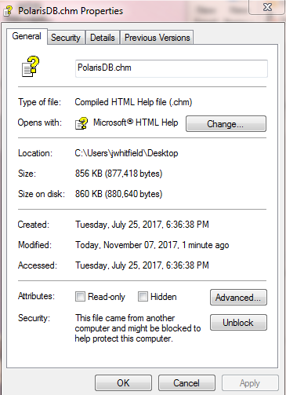

**Error message samples**

(A misspelled field name)

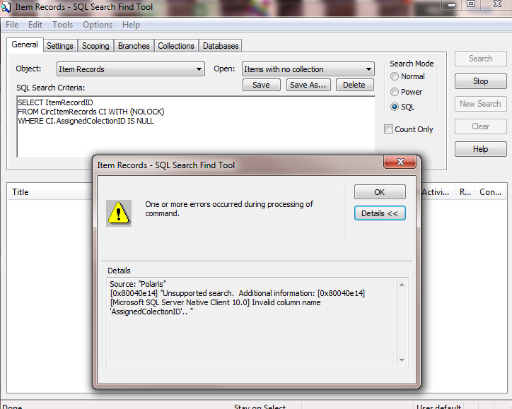

(A misspelled table name)

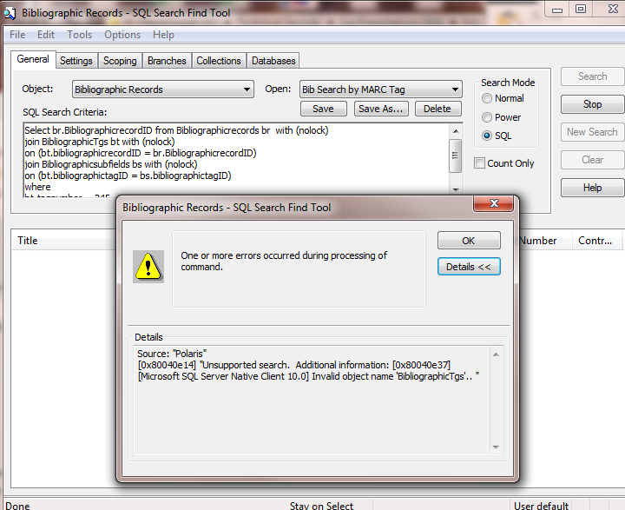

(Missing the "and" between two criteria)

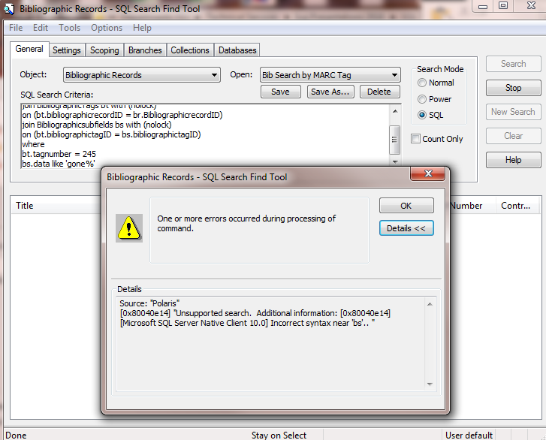

(A comment using double hyphens causing everything after them to be ignored.)

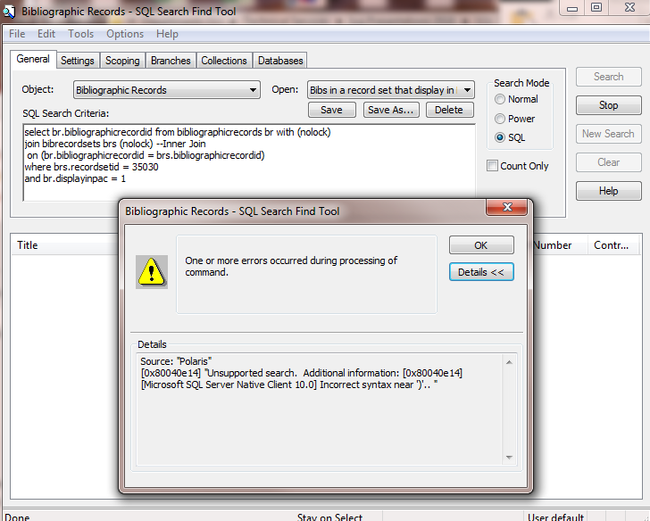

(An alias with a comma instead of a period (top line))

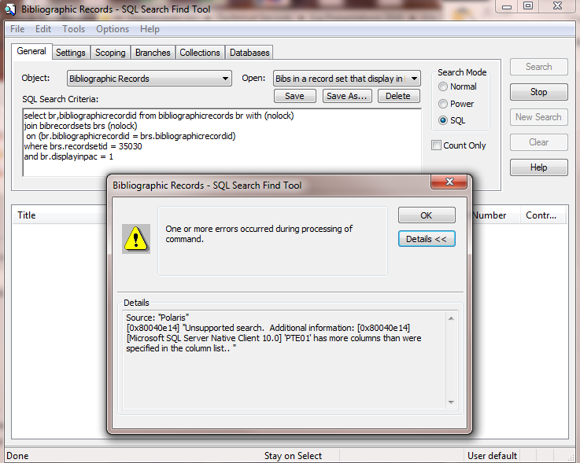

(Another alias error, this time in the join (third line))

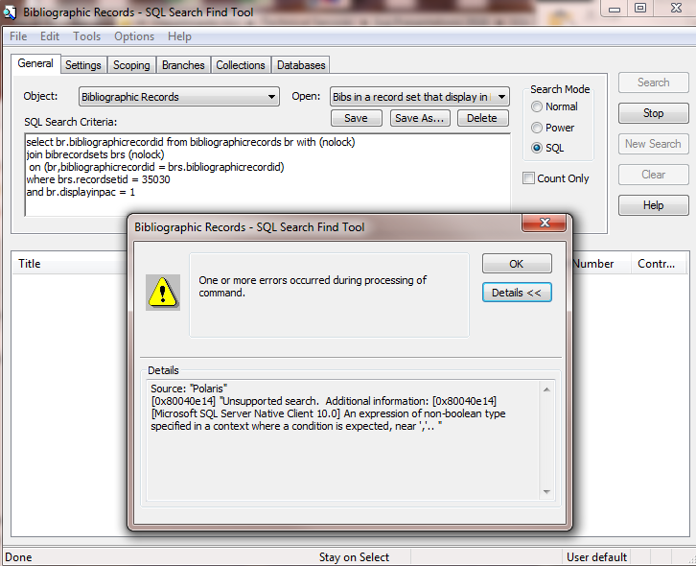

(A similar error message, but this time due to a minus or hyphen instead of an equals sign in the last criterion)

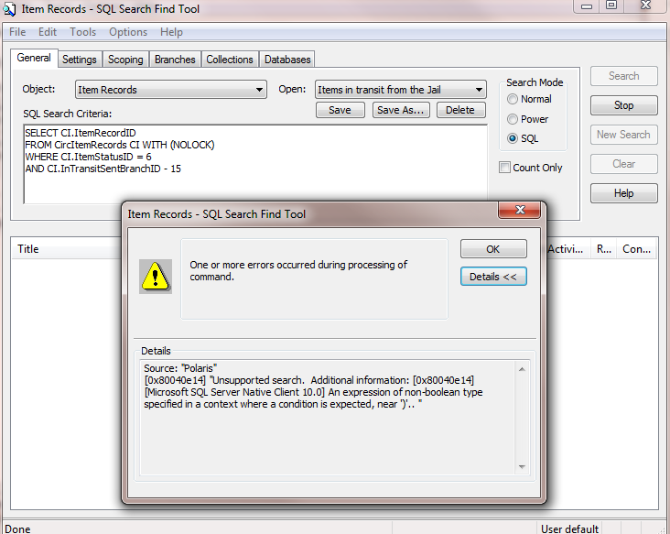

**Information for a Quick Reference Guide**

(Some of these values are standard across all Polaris versions. Others vary depending on the version. Still others are library-specific. Ask your IT department or System Administrator to provide these.)

Organizations (Branches) ID and Name

Collections ID and Name (if branches use different collections, get data from the OrganizationsCollections table)

Statistical Codes ID and Name (and Organization, if branches use different stat codes)

Record Statuses ID and Description

Item (Circulation) Statuses ID and Description

Item Loan Periods ID and Description

Item Blocks ID and Description

Shelf Locations ID and Description

Bib Type of Material ID and Description

Item Material Type ID and Description

Order Statuses ID OrderStatus (same values for POs and PO Lines)

Invoice Statuses ID and InvoiceStatus (same for Invoices and InvoiceLines)

Item Record History Actions ID and ActionTakenDesc